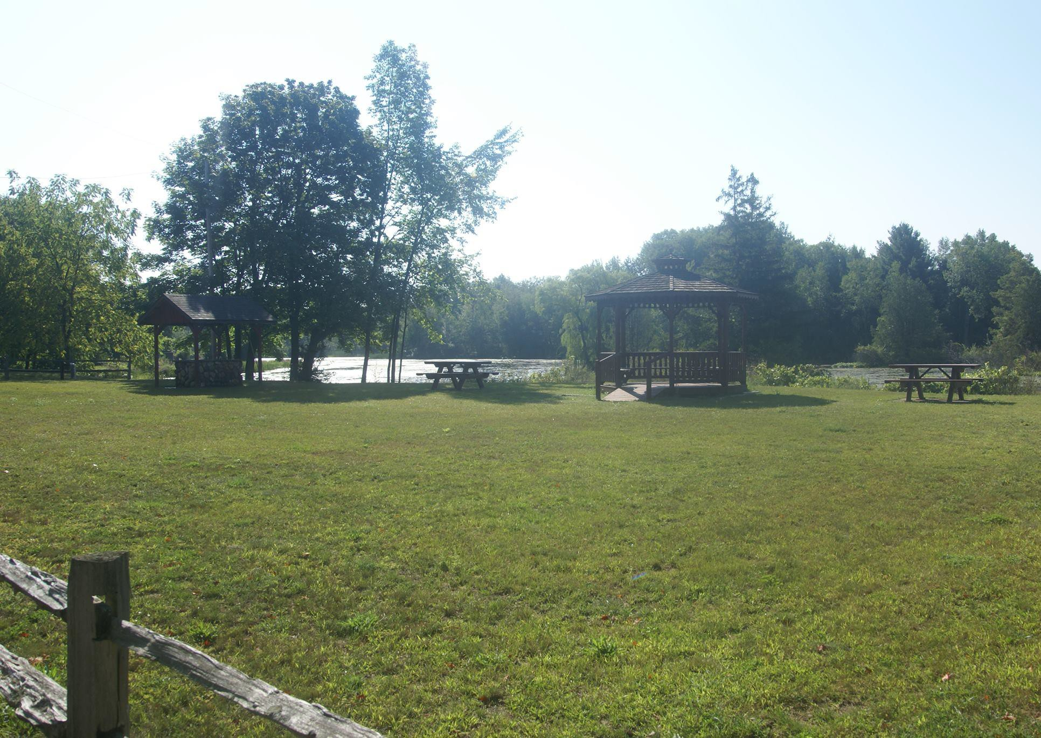
2

Village of Barryton &

Fork Township
Community Recreation Plan

Village of Barryton Council

James Soriano, President
Melissa Lazzaro, Deputy Clerk
Courtney Garchow, Treasurer
Kathryn Kerr, Trustee/Pro-Tempore
Evelyn Jones, Trustee
Michelle Kundrat, Trustee
Steven Hammond, Trustee

Fork Township Board

Lori Helmer, Supervisor Roberta Hazen, Clerk
Doug Brand, Treasurer
Mitch Mackersie, Trustee Tyler Martin, Trustee

Joint Recreation Committee

Kathryn Kerr
Melissa Lazzaro
Steven Hammond
Renee Earle
Dawn Tice
Melissa Babcock
Kathleen Tucker
Lori Helmer
Mitch Mackersie

Plan Adoption Record
Village of Barryton Council Adoption Fork Township Board Approval MDNR Approval

Table of Contents
Location Map 2
Introduction & Planning Process 3
Introduction 4
Description of Planning Process 5
Administrative Structures & Budgets 6
Recreation Facilities Non-Discrimination Policies and Barrier Free Compliance 8
Village of Barryton Recreation Budget 9
Fork Township Recreation Budget 10
Community Description 11
History 12
Items of Interest Concerning Fork Township 15
Location 16
Transportation 16
Utilities 18
Climate 18
Topography 20
Woodlands 21
Geology 21
Surface Water 22
Wetlands 22
Socioeconomic Characteristics 22
Recreation Inventories Village of Barryton and Fork Township 26
Recreation Inventories Mecosta County 33
Action Plan 52
Analysis of Needs, Goals & Actions 53
Village of Barryton and Fork Township Future Proposed Recreational Projects 54
Appendix 56
Potential Sources of funding 57
A Recommended Classification System for Local and Regional Recreation Open Space 58
Suggested Facility Development Standards 61
Grant History 64
Post-Completion Self-Certification Report 65

Location Map

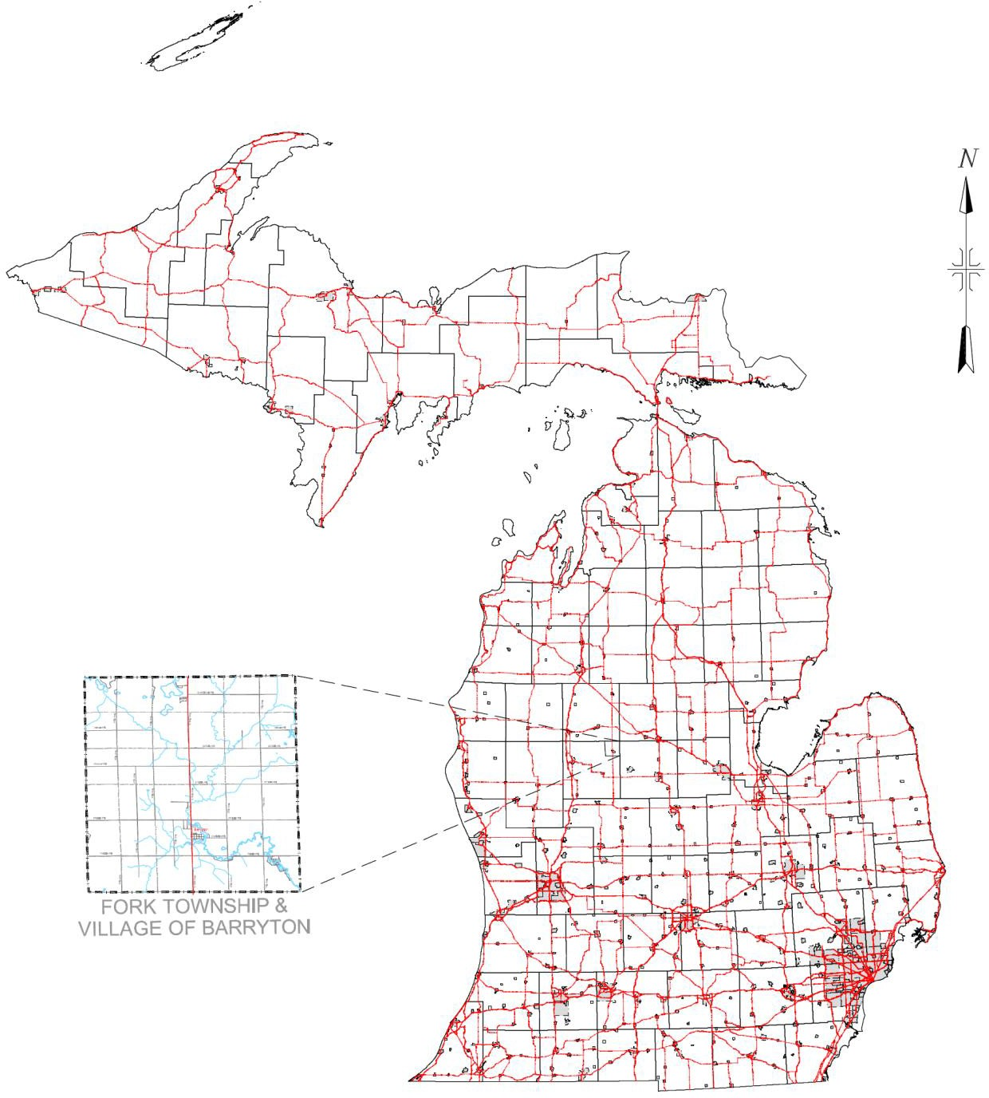

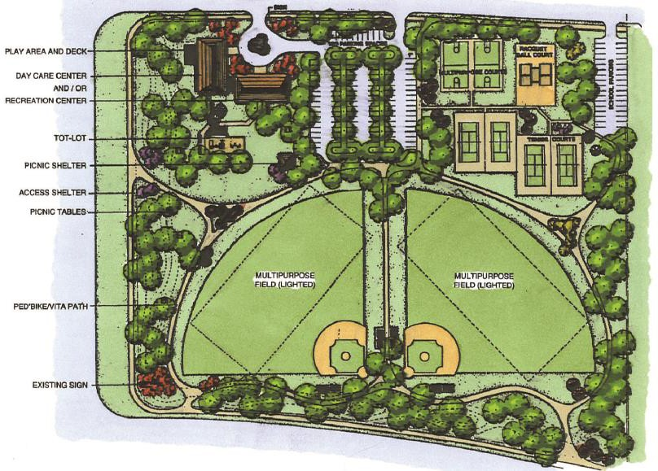
Introduction & Planning Process

Introduction

The Village of Barryton and Fork Township are located in a rural county with rich natural resources. Abundance of water and woodlands make recreation a significant part of their resident’s lives and their economy. The lands surrounding the many lakes have summer cottages and retirement homes but many tracts of land remain undeveloped. Many visitors are drawn to the county for these assets and the beauty of the area.

It is the purpose of this plan to provide the Village of Barryton and Fork Township with a useful guide for the future development of their parks and other recreational properties. The recreation plan will be a comprehensive plan to address the needs of youth, senior citizens, and visitors. The plan will establish goals and projects to meet the recreation needs of Fork Township and the Village of Barryton through the year 2028.

Description of Planning Process

In the summer of 2022 the Barryton Village Council determined it was time to rewrite its recreation plan. This village’s previous recreation had been accepted and added to the Mecosta County Recreation Plan. The previous village plan was expiring in 2022 and the council believed it was in the best interest of the village to rewrite the expiring plan. The council also thought that to prepare its recreation plan with Fork Township, the township that surrounds the village, would have advantages for both municipalities and the greater Barryton community.
In October the Fork Township board approved joining in the project. A joint Recreation Committee was established with members from both the village council and the township board plus members from the community at large. The committee subsequently met once a month for five months. The meetings were widely publicized by notices and newsletters. After inventories of existing recreation facilities were done, existing recreation facilities and opportunities were compared to national recreation standards, and potential projects were discussed at committee meetings and board meetings. Members of the recreation committee met with business owners and citizens to discuss the needed facilities. The new proposed projects include improvements and additions for both communities.
The draft recreation plan was completed in December of 2022 and made available for review at the village and township offices and the public library. Comments and suggestions received were addressed by the Joint Committee. Fork Township and Village of Barryton then approved the Five-Year Recreation Plan and submitted it to the Michigan Department of Natural Resources.

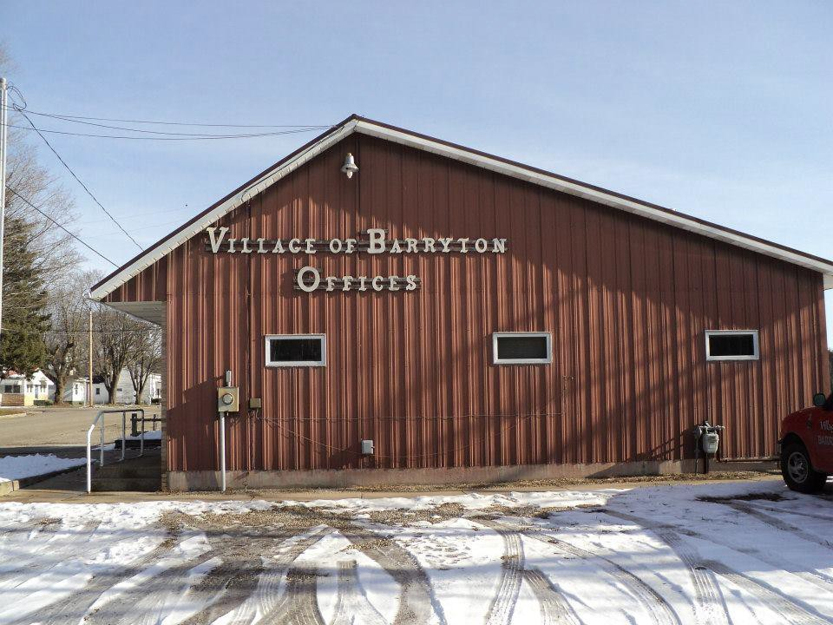
Administrative Structure & Budget

FORK TOWNSHIP BOARD
Lori Helmer, Supervisor
Roberta Hazen, Clerk
Doug Brand, Treasurer
Mitch Mackersie, Trustee
Tyler Martin, Trustee

VILLAGE OF BARRYTON COUNCIL
James Soriano, President
Melissa Lazzaro, Deputy Clerk

Courtney Garchow, Treasurer
Kathryn Kerr, Trustee/Pro-Tempore
Steven Hammond, Trustee
Michelle Kundrat, Trustee
Evelyn Jones, Trustee

JOINT RECREATION COMMITTEE
Kathryn Kerr
Melissa Lazzaro
Steven Hammond
Renee Earle
Dawn Tice
Melissa Babcock

Mitch Mackersie
Lori Helmer
Kathleen Tucker

Recreation Facilities Non-Discrimination Policies and Barrier Free Compliance

The Village of Barryton and Fork Township do declare, in accordance with MCL 125.1352, that any and all construction performed by or on behalf of the Village of Barryton and Fork Township within their limits, will comply with the State of Michigan and Federal Governments’ definitions and regulations to always be in compliance of barrier free standards as set forth by such.

The Village of Barryton and Fork Township are equal opportunity providers.

Village of Barryton Recreation Budget

FY 2022 Parks and Recreation Expenditures
- Salary and Wages
- Supplies
- Contract Services
- Insurance
- Utilities
- Repairs and Maintenance
Total = $XX,XXX

FY 2023 Preliminary budget is $XX,XXX plus allocations for projects identified
in this plan.

The Village of Barryton’s fiscal year (FY) begins in March.

Allocations for new projects will be included in the winter budget process.

Fork Township Recreation Budget

FY 2022 Parks and Recreation Expenditures
- Salary and Wages
- Supplies
- Contract Services
- Insurance
- Utilities
- Repairs and Maintenance
Total = $19,627.43
FY 2023 Preliminary budget is $27,300 ($7,300 for camera surveillance system) plus allocations for projects identified in this plan

Fork Township’s fiscal year (FY) begins in April.

Allocations for new projects will be included in the spring budget process.

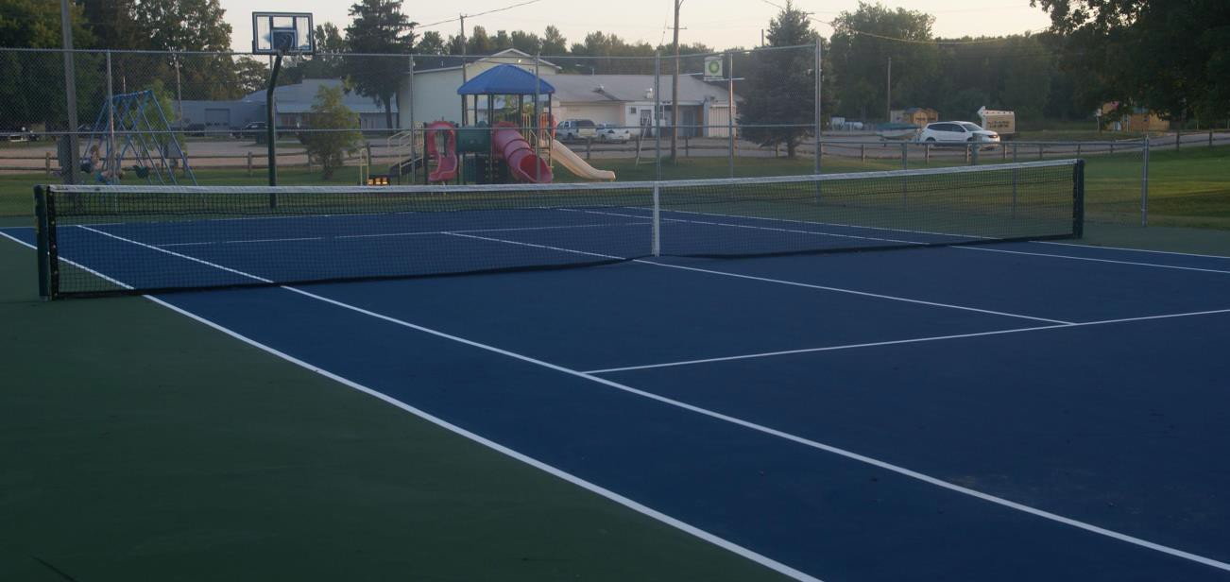
Community Description

History1

There is evidence of mankind being in Mecosta County 11,000 to 13,000 years ago. The rivers, streams, and plentiful wildlife were the attraction then and later to the Ottawa and Chippewa Indians who used the Little Muskegon, Muskegon, Chippewa Rivers, and many of the other tributaries before and after Europeans arrived. It is estimated that there were approximately 5,000 Native Americans from the Grand River in the Lower Peninsula to the Chocolate River in the upper peninsula of Michigan.
Mecosta County Historic Timetable 1840 – Established county boundaries 1855 – First permanent settlers
1858 – County officially organized 1859 – Established Village of Leonard 1869 – City of Big Rapids was
Incorporated
1869 – First railroads entered the county 1881 – Paris Fish Hatchery opened
1884 – Ferris Industrial School established 1893 – County Jail established

The earliest Europeans were traders, clergy, and soldiers. After 150 years Europeans, by benefit of guns, diseases, whiskey, and sheer numbers,
came to dominate Mid-Michigan. The influx of settlers began after the Erie Canal opened in 1825 making migration by the Great Lakes as easy, or easier than, the Ohio River route which had led to the settlement of the lower Midwest much sooner than Michigan. This new immigration from the northeast is evident by the numbers of New Englanders and New Yorkers who were the early settlers of the area.

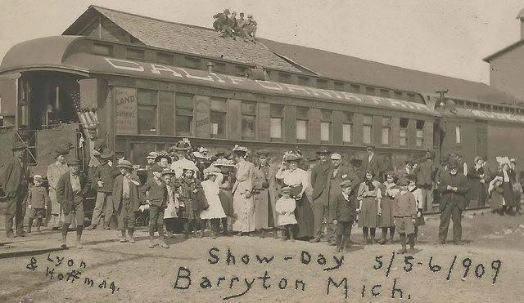
Mecosta County was originally part of Newaygo County and both Barryton and Fork Township were organized in the late 1860’s. Fork Township’s population in 1870 was 140 and in 1880 it was 343. The Village of Barryton was established in Fork Township at the juncture of the North and South Branches of the Chippewa River. Mecosta County was organized in 1858.

The timber boom in Michigan, which was to last through the end of the nineteenth century, had begun in the 1850’s. The dam in Barryton was built to facilitate running logs down the Chippewa River to Saginaw.

¹Most of the information for this section of the Recreation Plan was taken from Salt of the Earth by Dorothy Langdon Yates, published in 1987 by the Midland County Historical Society of The Midland Center for the Arts, Inc, Barryton My Home Town by Barbara G. Dean, 1950, and Village of Barryton, Michigan; Mecosta County 1894-1994; 100 Years Young; compiled by Norma & Everett Cope.

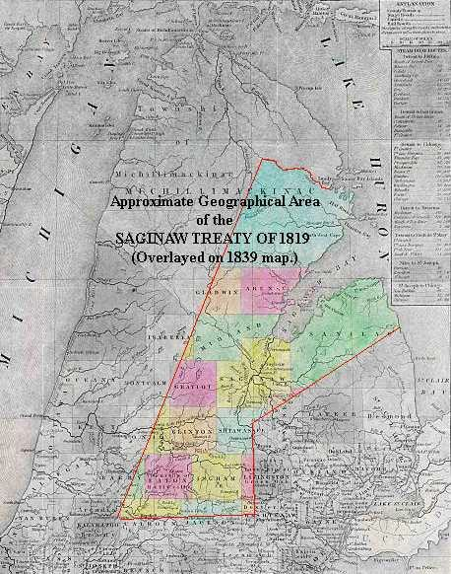
The Saginaw Bay watershed, which includes the Chippewa River, was used to float white gold (white pine logs) to sawmills in Saginaw, where they were converted to lumber and shipped on to the burgeoning East and Midwest. From 1851 to 1897, the last big year of this boom, the Saginaw River floated 25 billion board feet of lumber in pine logs, enough to build one million medium-sized homes. Michigan’s green rush was worth a billion dollars more than California’s gold rush.

During this time, the Tittabawassee Boom Company and the companies cutting the timber employed over 4,000 men and had as many as 130 miles of floating logs through Midland County to Saginaw. Waste wood was used to vaporize water from brine wells into salt as
Michigan supplied half the nation’s salt during the lumbering era. As the timber was cut, agriculture and other enterprises began in earnest. It is claimed as much timber was burned by settlers as was cleared by lumberman. Trappers and hunters came to the area to take advantage of the wild animals such as bears, wolves, lynx, bobcats, deer, beavers, muskrats, and mink which provided food and a profitable fur trade.

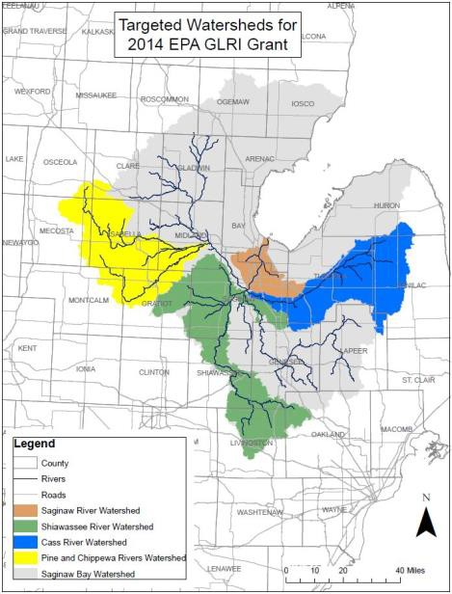
The Graduation Act of 1854, Homestead Act of 1862, and the new railroads, which usually received six miles either side of their tracks as an incentive to construct the railroad systems; conjoined to bring waves of farmers into the region. Most of the early settlers homesteaded 80 acres of land through the land office in Ionia.

The construction of the Flint and Pere Marquette Railroads was the key that unlocked Central Michigan and helped to bring many early settlers to Fork Township. Flint and Pere Marquette Railroad promoters even maintained an agent in Germany to promote land sales. A sawmill was built in 1894 at the forks of the Chippewa River and in November, the first train arrived in Barryton. Lumber was then shipped by rail for the next decade until the mill closed. (The
railroad continued operations until 1943 when the track was removed.)

Other early businesses that came to the area were a bank, hotels, grocers, and blacksmith shops, among others. Dr. Frank Berry came to the area in 1894 and opened a drug store on what would become Northern Avenue in Barryton. He purchased land and subdivided it creating the Village of Barryton. Two hotels were built soon after and the first saloon was opened in 1894 as well. The Post Office, which had been at Disciple, was transferred to

Barryton the same year. There was a flour and grist mill near the dam owned by John Settler, as well as a hoop and stave factory, and a shingle mill. An elevator was built on the railroad.

Unfarmable, cut-over lands went ultimately into tree farms, hunting and fishing businesses, or back to the State for non-payment of taxes. Many thriving timber towns in Mecosta County became ghost towns.

New settlers burned existing woodlands, used giant tripods and pulleys with horse teams to pull the huge white pine stumps, and sent hogs into the remaining woodlots to clear the rattlesnakes. With the invention of the steel plow (1830), the reaper (1834), and the tractor (1920), agriculture became the dominate land use in Mecosta County and the whole region. Various crops have predominated over the years from wild cranberries harvested by the Chippewa Indians through the mid-1800’s to chicory in the 1910’s. Dry beans were introduced after the Civil War and sugar beets in the 1890’s and corn, as its productivity increased, became a major crop in the twentieth century. Locally produced crops included potatoes, beans, and cucumbers for pickles. Small dairy farms dotted the Mecosta County landscape.

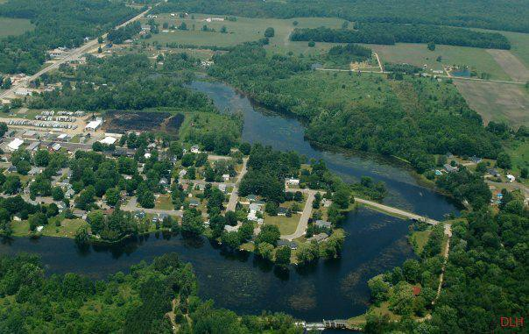
The last major event in the area’s early development was the discovery of petroleum oil in the twentieth century. Oil production in Mecosta County began in 1942. This production added to the area’s wealth and its urbanization. Severance taxes went to local communities and the state. This economic dynamism also added further impetus to the newly developing companies in the region.

As the roads and highways in Michigan were improved, the influx of summer residents and tourists began to grow significantly. Cottages and campgrounds were built around the many lakes and rivers. Notable developments just to the east of Barryton and Fork Township were Canadian Lakes and the Blue Lake Lodge.

Agriculture still is an important part of the landscape and economy of Fork Township. Dairying is still active; hog rearing, cattle farming, and potatoes, corn, soybean, and other crops are currently pursued in the township. The township has a number of small manufacturing and other commercial enterprises. Township and village service and retail businesses cater to local residents, summer residents, and tourists.

“Items of Interest Concerning Fork Township”

Marvin A. Rogers was the first white settler in Fork Township. In 1880 the population in Fork Township was 343. Mecosta County had a population of 13,973 and Big Rapids had 3,552 persons.

The equalized valuation of properties in Fork Township in 1868 was $64,096.00. In 1883 the value had risen to $122,705.00.

The first supervisor, William Creevy, was elected in 1867 and the total vote in November of 1882 was 43.

The first white child born in the township was on August 21, 1866 and the first death in the fall of 1869. The first marriage was solemnized in the fall of 1867.

The first framed building was erected in 1870 and the first schoolhouse was a log building also erected in 1870. Lewis Scott opened the first store in 1875 and the first post office was established in 1860 at Fork.

Location
City/Village | Distance from  the Village of Barryton (miles)
Big Rapids | 21.1
Evart | 15.9
Reed City | 29.4
Clare | 23.6
Remus | 10.8
Mt. Pleasant | 29.7
Grand Rapids | 76.1
Lansing | 100
Detroit | 185

The Village of Barryton is in Fork Township located in the northeast corner of Mecosta County. The village is on M-66 where the north and south branches of the Chippewa River come together. It is the only village in Fork Township. The village encompasses approximately 1.04 square miles. It is bounded by 20 Mile Road on the north, 35th Avenue on the west, 19 Mile Road on the south, and 20th Avenue on the east.

There are several small cities within 40 miles of Barryton. Distances to these and other Michigan cities are listed in the table at the right.

Transportation

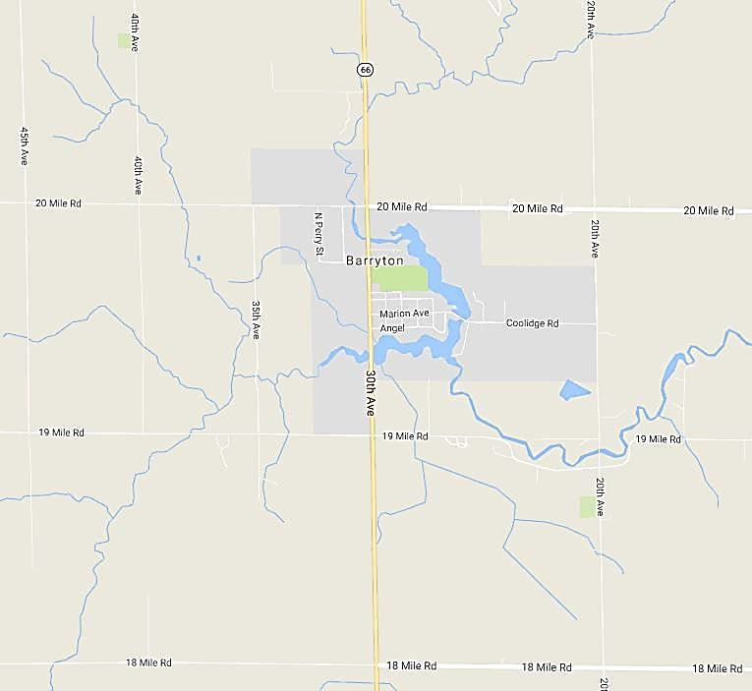
Road Systems

There are four main roadways near the Village of Barryton. U.S. Highway 10 runs east- west through Osceola County about 12 miles north of the village and M- 20 runs east-west through Remus about 12 miles south of the village. U.S. Route 131 runs north- south through Big Rapids in western Mecosta County. M-66 runs north- south through Barryton.

U.S. Highway 10, north of the village, is a two-lane undivided highway
running through rural areas of western and central Michigan. U.S. 10 meets M-66 north of Barryton and meets U.S. 131 just west of Reed City. M-20 is a major east-west travel corridor in the central Lower Peninsula. The highway starts near Lake Michigan at U.S. 31 and goes east to Midland. U.S. Route 131, a north-south United States highway, starts at the Indiana state line and ends in Petoskey. M-66 is a north-south state trunk line highway in the Lower Peninsula. Most of the highway is two-lane rural highway. It runs from the Indiana

state line to Charlevoix. M-66 runs through the western part of Barryton. The annual average daily traffic on M-66 through Barryton is 3,777 vehicles.

Almost all of the roads within the village limits are asphalt paved and are maintained by the Village Department of Public Works.

Airports

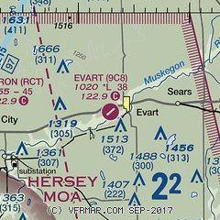
Evart Municipal Airport is located one mile southwest of Evart. It is publicly owned and approximately 16 miles from Barryton. The runway is 3804’ x 75’ with an asphalt surface and has an average of 60 operations a month. There are five aircraft based at the field: one single engine airplane and four helicopters.

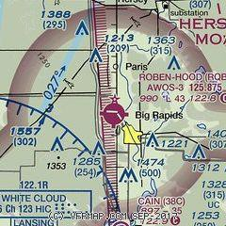
Roben-Hood Airport is located on the Durfey farm just north of Big Rapids. It is publicly owned and approximately 24 miles from Barryton. The runway is 4300’ x 75’ with an asphalt surface and an average of 77 operations a week. There are 19 single-engine airplanes, two multi-engine airplanes, one helicopter, and 1 ultra-light based at the airport.

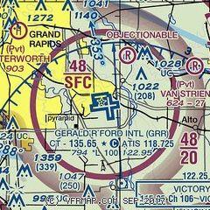
Gerald R. Ford International Airport is located in Grand Rapids approximately 80 miles from Barryton. The airport is owned by Kent County and managed and operated by the Airport Authority under the direction of the Gerald R. Ford International Airport Authority Board. The airport has been operating since 1926. Today the airport has six airlines offering 120+ daily nonstop flights to 24 cities. Total annual operations include passenger, aircraft operations, and cargo.

Public Transportation

Mecosta Osceola Transit Authority (MOTA) provides curb-to-curb service public transportation throughout Mecosta County. Operation hours are from 5:00 AM to 7:00 PM Monday through Friday with a fleet of ten lift-equipped vehicles.

Utilities

The Village of Barryton is served by a municipal sewer system and a storm water system that services most of the village. The storm sewers on M-66 are owned and maintained by the Michigan Department of Transportation. Property owners have individual wells for potable water.

Consumers Energy provides electrical service to Barryton residents. DTE Energy provides natural gas service. Other residents rely on propane, woodstoves, or some other form of alternative heat.

Frontier Communications, along with Point Broadband, are the providers of local telephone and internet services for the village. There are currently 40 wireless communication towers located in Mecosta County providing both cell phone and internet service, a vital need in encouraging economic growth in rural areas such as the Village of Barryton. The local tower on 20 Mile Road is owned by Verizon. There are currently no cable services in the village.

Climate

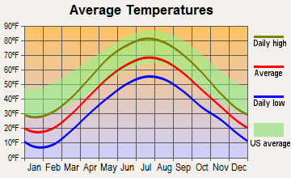
The temperatures in the Village of Barryton range from a daily average low temperature of 14.5°F in January to an average high temperature of 77°F in July. The lowest average temperature of the year is usually recorded in January. The average annual temperature for the area is
68.9°F. Average temperatures in the Village of Barryton fall below the United States averages for all months of the year.

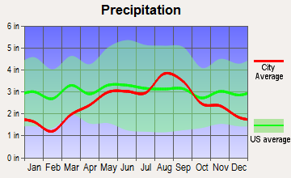
Total annual average precipitation in the village is 32.1 inches. October tends to have the highest amounts of rainfall with averages of 3.35 inches. February has the lowest amount of precipitation with an average of 1.3 inches. Average precipitation in the Village of Barryton is consistent with the United States for most of the year.

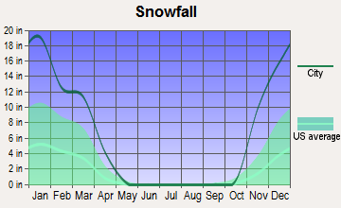
Normally, January has the most amount of snowfall with an average of 22 inches. The next highest snowfall month is December with 20.5 inches. Snowfall averages in the Village of Barryton are above the United States average for the year.

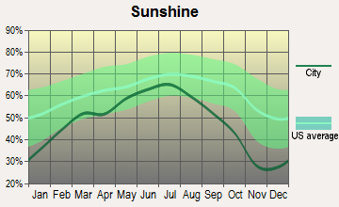
The month of July has the highest percentage of sunshine at 65%. The month of December has the lowest percentage of sunshine at 25%. The Village of Barryton is below the United States average for sunshine for all months of the year.

Above average snowfall makes the Village of Barryton and surrounding areas popular and desirable areas for snowmobiling, cross country skiing, and snowshoeing in the winter. These activities draw tourists and visitors to the area.

Topography
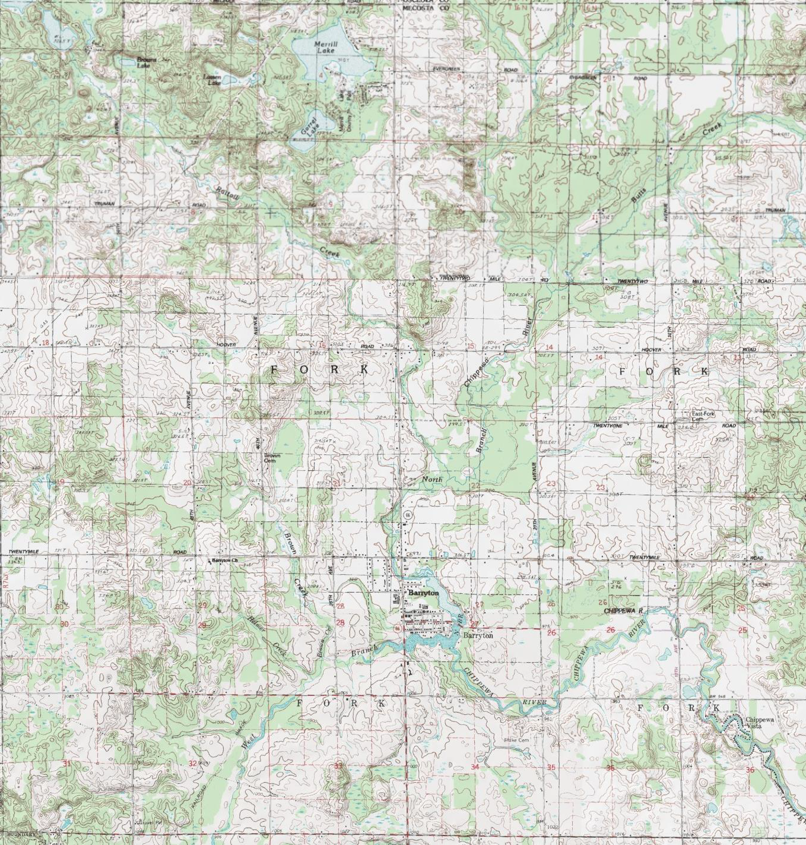

There are 35.3 total square miles in Fork Township; 35.0 square miles of land and 0.3 square miles of water. Land features in Fork Township and the Village of Barryton are the result of two glacial basins. When Lake Michigan and Saginaw Glacial lobes began melting and depositing their debris, they left undulating to sloping moraines throughout most of Mecosta County creating a two to three-mile-wide valley known as the ancestral Muskegon River. Another outwash plain was formed by water from the Saginaw Lobe. The Little Muskegon and Chippewa Rivers are in these one to six-mile-wide plains. The glaciers left behind in Fork Township and the Village of Barryton are sand and gravel deposits called Glacial Outwash Plain. The glacial till and outwash deposits formed soils that are loamy and sandy,

from excessively drained to poorly drained, and nearly level to gently rolling and steep terrains.

Woodlands

Woodlands cover approximately 160,000 acres, 44% of Mecosta County. The soils in these woodlands are generally too wet, too sandy, or too steep for agriculture purposes. The vast majority of for forested land in Mecosta County is held in private ownership (78.70%). The State of Michigan holds the second largest amount of forestland (12.67%) with its various recreational and State Forest areas. Approximately 2,249 board feet of timber is harvested yearly in Mecosta County.

Geology

Mecosta County was completely covered by a series of glaciers during the Pleistocene Epoch. The glaciers left deposits from 450’ to 825’ thick on the original bedrock of shale and limestone creating the present topography and soil material. The high concentration and abundance of gravel deposits make Mecosta County a great location for mining and mineral extraction operations and provide varied and interesting terrain for recreation.
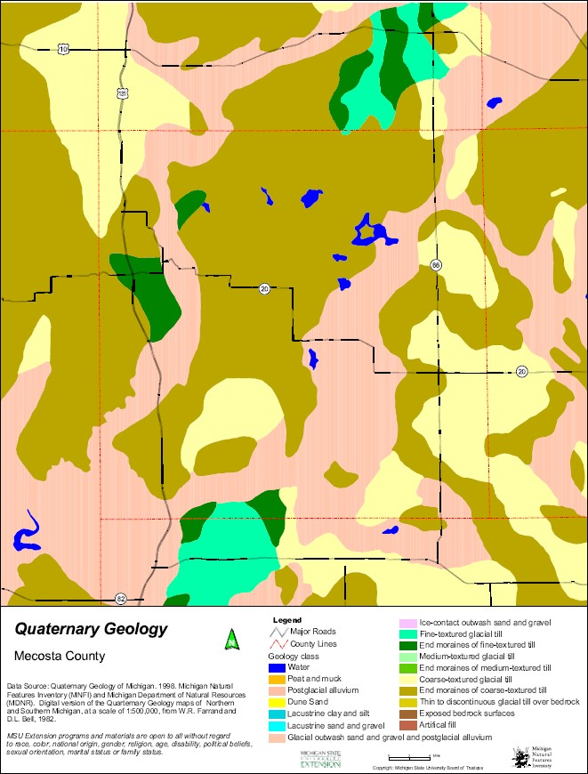

Surface Water

Approximately 2% of the surface area in Mecosta County is covered with water in the form of lakes, rivers, ponds, streams, and creeks. With wetlands and flooded areas, the surface area increases to 16% coverage. The MSU Extension Office estimates there are approximately 399 lakes and ponds in Mecosta County with approximately 35 inland lakes 14 or more acres in size. There are over 480 miles of rivers and streams and an estimated 8,827 acres of natural and artificial lakes and ponds. The major river systems are the Muskegon River, Little Muskegon, and the Chippewa River. Major water resources are located in Canadian Lakes, the Martiny and Haymarsh Flooding Projects, and the Muskegon River.

Wetlands

Mecosta County is located within three major watersheds: the Muskegon River Basin, Saginaw River Basin, and the Grand River Basin. These three major watershed basins extend to 34 sub-basins within the county. It is estimated that there are 51,922 acres of wetlands in Mecosta County. Approximately 29,960 acres of the wetland area in the county is forested. Haymarsh State Game Area, Canadian Lakes, and the Martiny Lakes are manmade flooding areas. Wetlands are mainly associated with floodplain areas along the rivers, streams, and lakes.

Socioeconomic Characteristics

Population Fork Township
The population in Fork Township was 1,435 according to the 2020 American Community Survey.
Females account for 48% of the population and males 52%. The township is predominately white
(95.1%). The median age of township residents in 2020 was 50.3 years. The largest percentage of
township residents 25 to 44 years-of-age followed by 263 aged 55 to 64 years, and 230 aged 65 to
74 years.

Village of Barryton

The population in the Village of Barryton was 405 according to the 2020 American Community
Survey. Females account for 52% of the population and males 48%. The village is predominately
white (95.3%). The median age of village residents in 2020 was 49.1 years. The largest percentage of
village residents are in the 60 to 69 years-of-age followed by 46 aged 0 to 9 years, and 37 aged 40 to
49 years.

Housing

Fork Township

As of 2020 there were 927 housing units in Fork Township, 673 units were occupied and 249
units were vacant. The average household size for owner-occupied housing is 2.1 persons and
2.4 for renter-occupied housing. The average for all units is 2.13. The average family size is
2.88. There are 512 one-unit detached dwellings, one unit attached, 5 three or four units, and 8
ten or more units, and 145 mobile homes. The township is reported to have 222 seasonal homes.
The median household income in 2015 was $29,741; in 2020 was $55,536. Of the reported
home-owner units, 273 have mortgages had mortgages and 271 do not.

Most housing was built before 1980. Twenty-one units were built since 2010, 91 units were built from 2000 to 2009, 183 from 1980 to 1999, 195 from 1960 to 1979, 121 from 1940 to 1959, and 62 1939 or earlier. The majority of homes heat with utility gas or LP gas. All households have complete plumbing facilities, one lacks complete kitchen facilities, and 19 have no telephone service.

Village of Barryton

As of 2020 there were 188 housing units in the Village of Barryton, 144 units were occupied
and 44 units were vacant. The average household size for owner-occupied housing is 2.1 persons
and 2.4 for renter-occupied housing. The average for all units is 2.13. The average family size is
2.92. There are 512 one-unit detached dwellings, one unit attached, 5 three or four units, and 8
ten or more units, and 145 mobile homes. The village is reported to have 222 seasonal homes.
The median household income in 2015 was $29,741; in 2020 was $55,536. Of the reported
home-owner units, 273 have mortgages had mortgages and 271 do not.

Most village housing was built before 1960. Nine units were built from 2000 to 2009, 8 from 1990 to 1999. 10 from 1980 to 1989, 21 from 1970 to 1979, 35 from 1960 to 1969, 39 from
1950 to 1959, 17 from 1940 to 1949, and 52 1939 or earlier. The majority of residents heat with utility gas. Seventeen households have no telephone service.

Twenty-six renters in the village pay $500.00 or less, 21 pay $500.00 to $999.00, and 5 pay
$1,000.00 to $1,499.00.

Employment Fork Township
Out of a population of 1,435 in 2020 there were 567 residents of work force age in the township
of which 525 are employed and 42 unemployed. The employment rate in 2020 for the township
was 42.5%. Forty-two percent of all residents in Fork Township are at or below poverty level.

The main economic sectors in 2015 in Fork Township were Production (9.6%), Service
(7.0%), and Management, Business, and Science (6.9%). The mean travel time to work is 34
minutes. Fifty-six-point nine percent of working residents work within the county, 41.5% work
outside the county, and 1.6% work out of state. The median household income in 2015 was $29,741.
The median family income in 2020 was $55,536. Eighty-one residents reported not having health
coverage in 2020.

Thirty residents reported an income of less than $10,000, 61 residents $10,000 to $14,999, 95
residents $15,000 to $24,900, 82 residents $25,000 to $34,999, 152 residents $35,000 to $49,900,
117 resident $50,000 to $74,999, 79 residents $75,000 to $99,999, 49 residents $100,000 to $149,999,
8 residents $150,000 to $199,999 and zero residents $200,000 or more.

Of the 762 residents aged 25 to 64 years, 94 have less than a high school education, 327 have a
high school diploma or equivalent, 251 have an Associate’s Degree or some college, and 90
residents have a Bachelor’s Degree or higher.

Village of Barryton

Out of a population of 405 in 2020 there were 268 residents of work force age in the village of these 115 are employed and 4 are unemployed. The unemployment rate in 2020 for the township was 23.1%. Forty-two percent of all residents in the Village of Barryton are at or below poverty level.

The main economic sectors in the Village of Barryton are Education, Health, and Social (31.0%), Manufacturing (22.3%), and Retail Trade (11.7%). The mean travel time to work is 28 minutes; 62.6% work in the county, 33.3% work outside the county, 4% work out of state, and 2% work at home. Thirty-seven-point eight percent of the families in the Village of Barryton are below poverty level. Twenty residents reported having no health coverage in 2020. Thirteen residents reported an income of less than $10,000, nine residents reported $10,000 to $14,999, forty-two reported $15,000 to $24,900, twenty-two reported $25,000 to
$34,999, fourteen reported $35,000 to $49,900, thirty reported $50,000 to $74,999,
eighteen $75,000 to $99,999, twelve $100,000 to $149,999, one $150,000 to $199,999 and zero
$200,000 or more.

Of the 26 residents aged 18 to 24 years 10 have less than a high school education, 7 have a high school diploma or equivalent, 9 have an Associate’s Degree or some college, and no residents have a Bachelor’s Degree or higher. Of the 236 residents aged 25 years or older 3 have less than a 9th grade education, 26 have a 9th to 12th grade education but no high school diploma, 79 have a high school diploma or equivalent, 70 have some college education but no degree, 14 have an Associate’s Degree, 36 have Bachelor’s Degree, and 8 have a Graduate or Professional Degree.

Recreation Inventories
Village of Barryton and Fork Township

The following inventory table displays the existing recreational facilities in the Village of Barryton. The tables include a description of each facility and a notation of the ownership. All of the facilities within the village are in good to excellent condition and are handicap accessible.

Village of Barryton Recreation Facilities Inventory

Facility Name | Description | Owner
1 Central Park | Approximately 18 acres, two picnic pavilions, 22’x44’ and 28’x65’, 18 picnic tables, two barbeque grills, men’s and women’s restroom, two horseshoe courts, one tennis court with basketball backboard at each end, artesian well, kiosk/pavilion with picnic table and grill, two benches, approximately 1,300’ walking trail with four benches, 24’x24’ fishing dock/pond overlook, farmers market pavilion with two benches, and playground area with swings and climbing structures.  ٭ Accessibility ranking of 3. | Village of Barryton
2 East River Park | Approximately ½ acre, playscape with swings, balance beam, and merry-go-round, gazebo, two picnic tables, and two grills.  ٭ Accessibility ranking of 3 | Village of Barryton
3 Barryton Lions  Club Riverside Park | Gazebo, two picnic tables, and artesian well.  ٭ Accessibility ranking of 2 | Village of Barryton
4 Barryton Elementary School | Playgrounds, swings, climbing and exercising structures, benches, spring riding animals, and merry-go-rounds, two soccer fields with goals, two ball fields with backstops, and ½ basketball court with backboard.  ٭ Accessibility ranking of 3 | Chippewa Hills School District

*Accessibility Assessment
All items listed in the recreational facilities inventory for Fork Township and the Village of Barryton have been graded for accessibility based on the following ranking:

1 = none of the facilities/park areas meet accessibility guidelines.
2 = some of the facilities/park areas meet accessibility guidelines.
3 = most of the facilities/park areas meet accessibility guidelines.
4 = the entire park meets accessibility guidelines.
5 = the entire park was developed/renovated using principles of universal design.

Village of Barryton Recreational Facilities Map
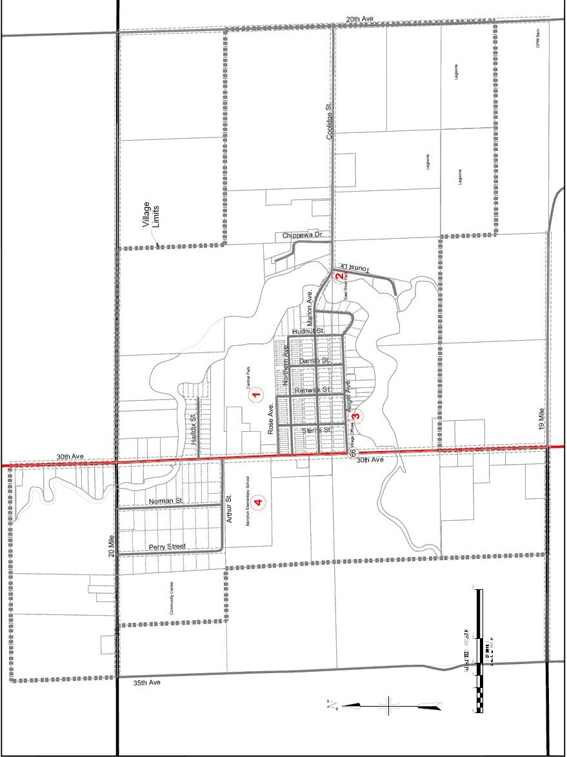

Central Park Map
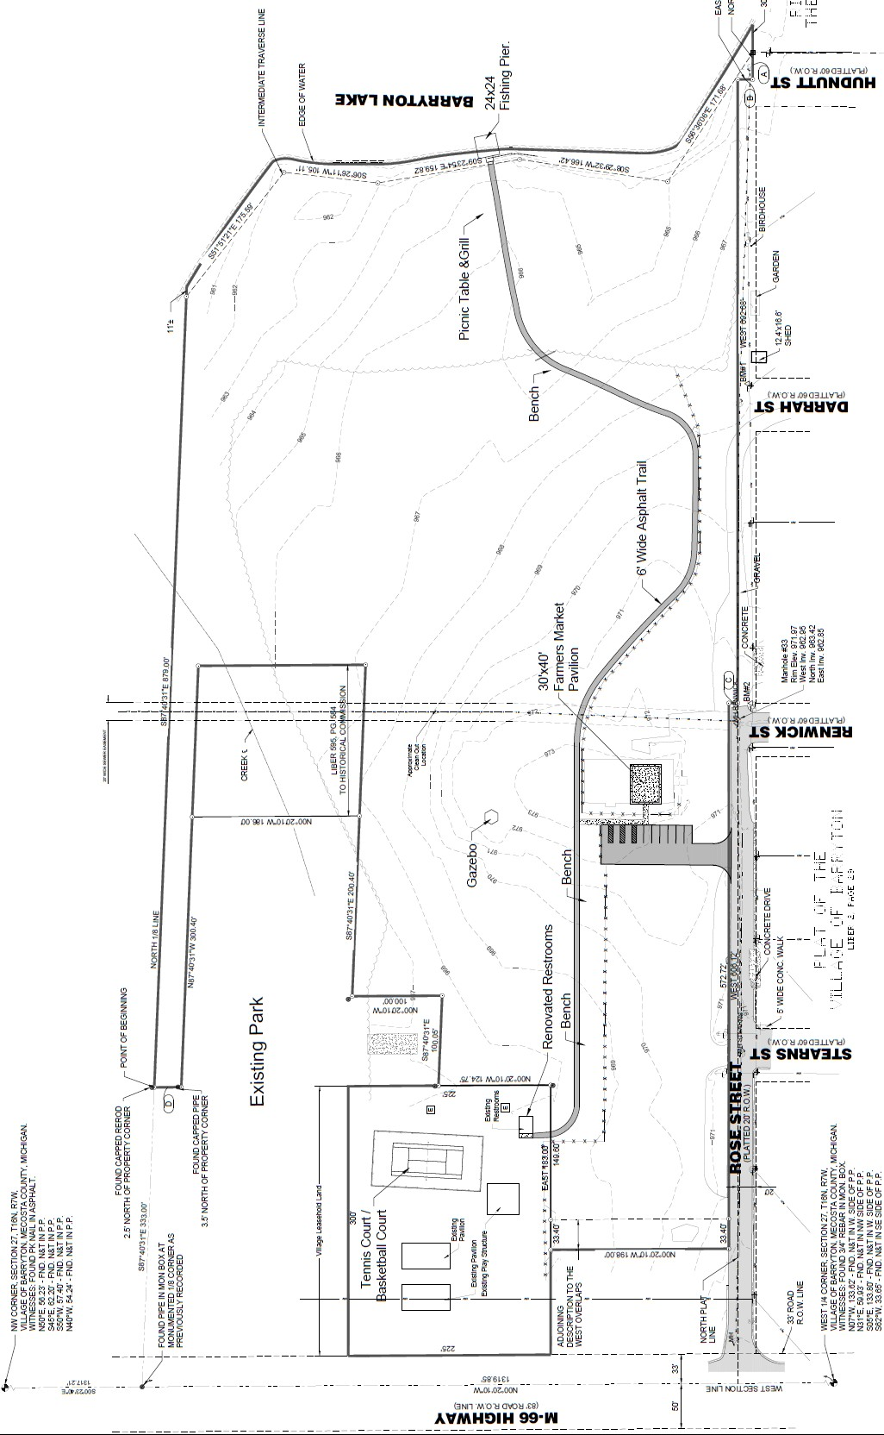

Facility Name | Description | Owner
Fork Township Community Center | The Community Center and Recreational Park is situated on 20 acres, which includes a 7,200 square foot indoor event space and a 18 acre recreational park. The indoor facility includes a 3,840 square foot event hall (300 person capacity), a commercially equipped kitchen, ADA compliant restrooms, a large paved parking lot, and a walk-in cooler. The recreational park includes a lighted 5,600 square foot covered pavilion with 64 picnic tables, a stage, and refreshment area; public restrooms; two baseball fields with dugouts and bleachers; a playscape; six horseshoe pits; a truck/tractor pull facility, and a paved walking path. A camera security system was recently installed that provides continuous surveillance of both the indoor and outdoor areas.  *Accessibility ranking of 3 | Fork Township

Fork Township Recreation Facilities Inventory

The following inventory table displays the existing recreational facilities in Fork Township. The tables include a description of each facility and a notation of the ownership. All of the facilities within the township are in good to excellent condition and are handicap accessible.

All items listed in the recreational facilities inventory for Fork Township and the Village of Barryton have been graded for accessibility based on the following ranking:

1 = none of the facilities/park areas meet accessibility guidelines.
2 = some of the facilities/park areas meet accessibility guidelines.
3 = most of the facilities/park areas meet accessibility guidelines.
4 = the entire park meets accessibility guidelines.
5 = the entire park was developed/renovated using principles of universal design.

Fork Township Recreational Facilities Map

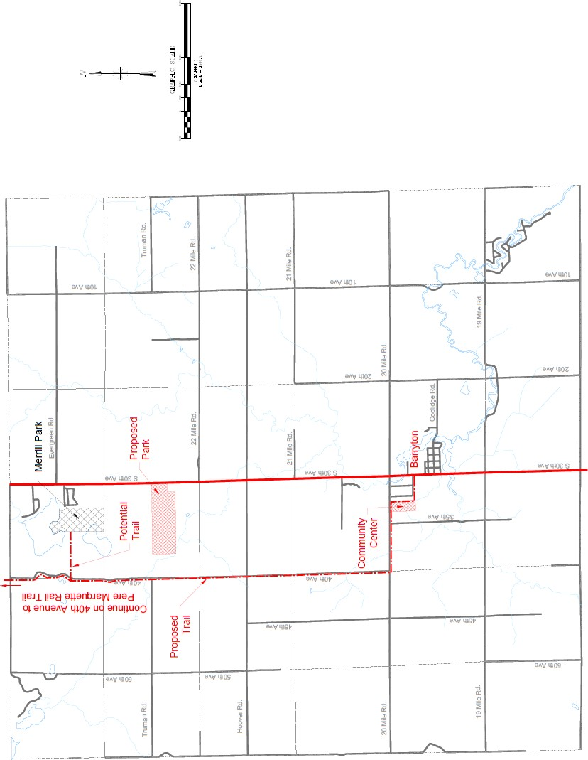

Inventory of Major Events
in the Village of Barryton and Fork Township

Many of the special events and celebrations in Barryton and Fork Township are held at their parks. Among these events are:

- Lilac Festival
- Fourth of July
- Barryton Days Homecoming
  - Tractor Pull
  - Truck Pull
- Old Fashion Christmas
- Harvest Festival
- Winter Festival
- Movie Nights in the Park

Service Clubs Involved in Local Recreation

- Lions
- American Legion
- Barryton Area Food Pantry

Recreation Inventories
Mecosta County Facilities

Mecosta County Recreation Facilities Inventories Map
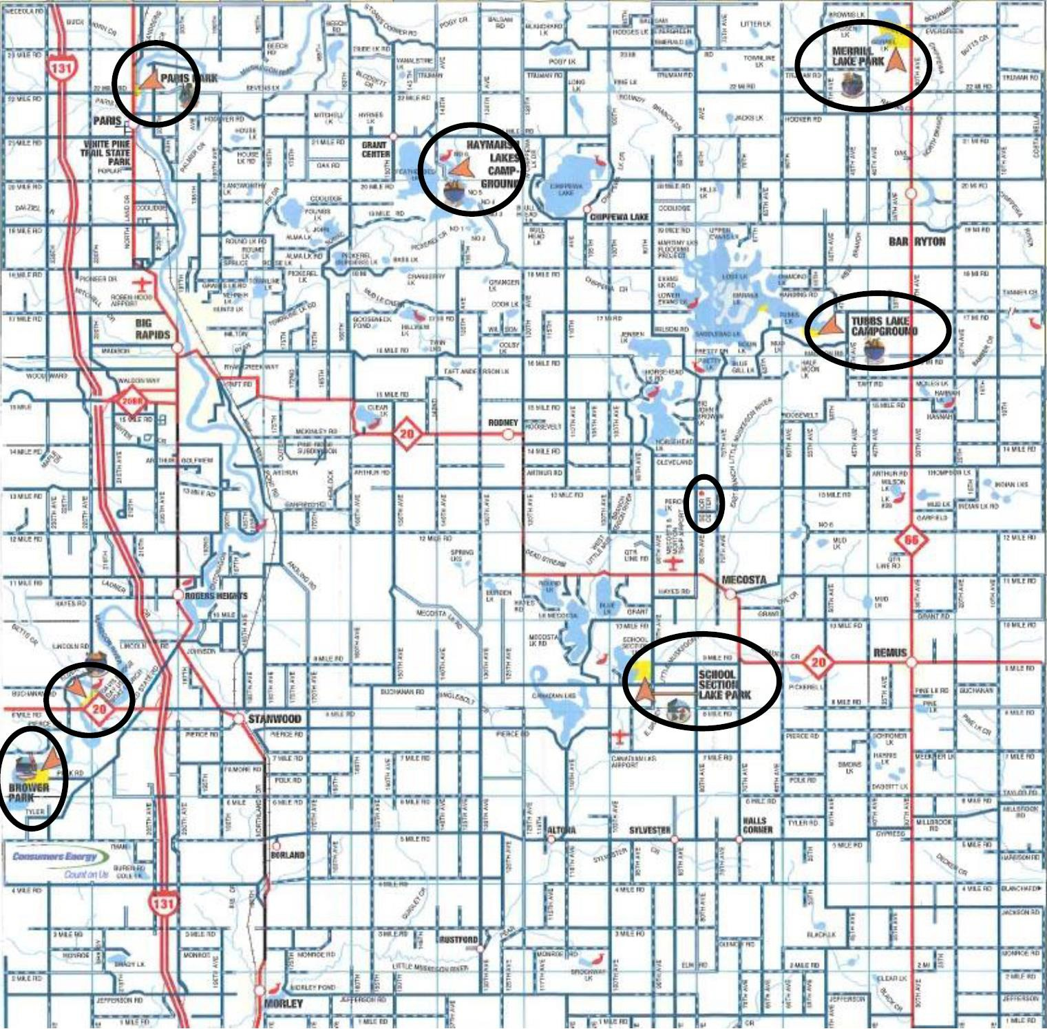

Mecosta County Recreation Facilities Inventories

Facility Name | Description | Owner
Brower Park | Two-hundred eighty acres, 230 campsites with water and electric hookups, ten rustic cabin sites, 8,000 feet of water frontage with 1,000 feet of sandy beach, three modern bathhouses, picnic areas, arts/crafts/programming building, updated playground facilities, two boat launches, two tennis courts, multi-purpose court, softball diamond, and movie  amphitheater. | Mecosta County
Davis Bridge | Provides access to the 18-mile-long Hardy Dam Reservoir, day use area including a boat launch, picnic facilities, entrance roads, parking for 10-15 vehicles and 25-30 vehicle/boat trailer units, entry contact stations, and shoreline and erosion  stabilization to improve shoreline fishing access on the Muskegon River. | Mecosta County
Merrill-Gorrel Campground | Ninety acres, frontage on two lakes (Merrill Lake and Gorrel Lake), 150 campsites with water and electricity, modern shower building, swimming beach, boat ramp and dock, picnic area, shelter building, playground equipment, 24 rustic sites, four  rustic cabins, ball diamond, horseshoe pits, and two basketball half courts. | Mecosta County
Paris Park | Fifteen acres, on the Muskegon River, 68 campsites with water and electric hookup (20 have full hookup), three rustic cabins, modern shower buildings, picnic shelter, covered stage, canoe and tube launch, shaded picnic areas, horseshoe pits,  playground, volleyball court, and a basketball half court. | Mecosta County
School Section Lake Veterans Park | Eighty-five acres, 165 campsites with water and electric hookups, five rustic cabins, two modern shower buildings, one beach bathhouse and a concession building overlooking the swimming beach, four picnic shelters, four shaded picnic areas, Little River School , a historical one-room schoolhouse, at the park entrance, playground equipment throughout park, two ball diamonds, horseshoe pits, volleyball court, basketball full court, and a family group camp with six rustic cabins and a main lodge  housing a kitchen and dining area. | Mecosta County
Mecosta County Fairgrounds | Annual county fair and carnival, campgrounds, and equestrian facilities located in Big Rapids | Mecosta County Free  Fair

City of Big Rapids Recreational Facilities Inventories Map

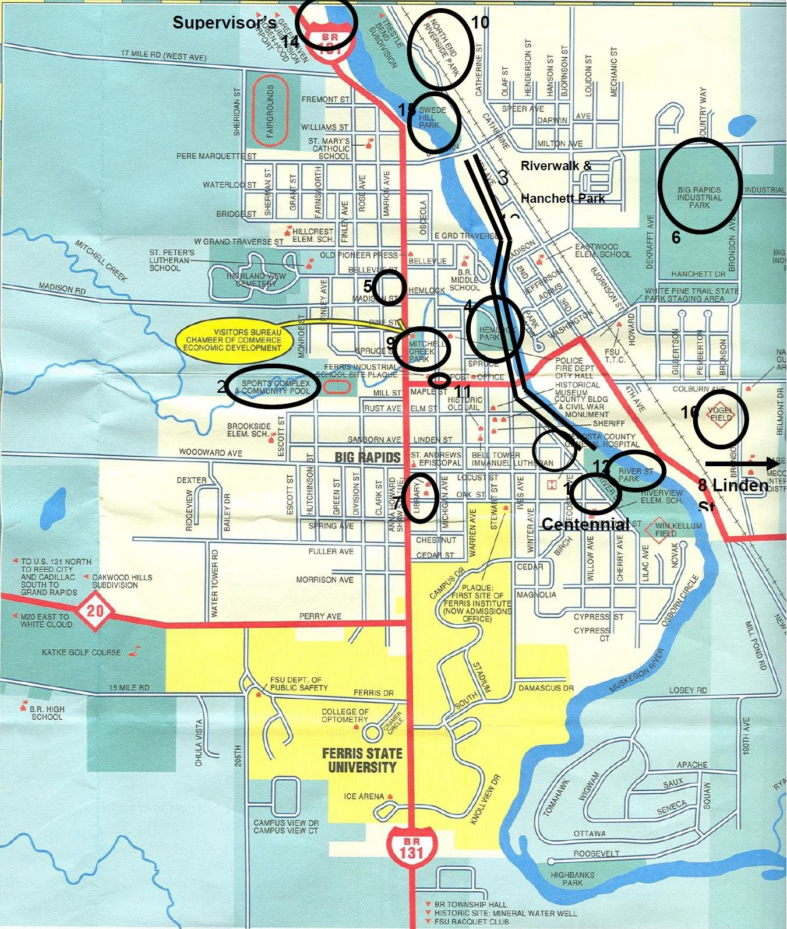

City of Big Rapids Recreational Facilities Inventories

Facility Name | Description | Owner
Brutus Dog Park |  | City of Big Rapids
Centennial Park | Playground and shelters | City of Big Rapids
Charles E. Fairman  Community Pool | Picnicking, swimming, restroom, shower, shelters, concessions, and nature area | City of Big Rapids
Clay Cliffs Nature Area | Trails | City of Big Rapids
Hanchett Park | Picnicking, fishing, nature area, and trails | City of Big Rapids
Hemlock Park  with Bandshell | Picnicking, playgrounds, fishing, restroom, shelters, athletic  field, court games, winter sports, and trails | City of Big  Rapids
Holland Park | Picnicking, programming, and historical site | City of Big Rapids
Industrial Park Ball Field | Athletic field | City of Big Rapids
Library Park | Historical site | City of Big Rapids
Linden Street Park | Picnicking and playgrounds | City of Big Rapids
Mitchell Creek Park | Picnicking, restroom, and historical site | City of Big Rapids
Northend Riverside Park | Picnicking, playgrounds, fishing, restroom, shelters, nature area, court games, winter sports, water sports, and trails | City of Big Rapids
Pocket Park |  | City of Big Rapids
River Street Park | Fishing, restroom, athletic field, court games, winter sports, and trails | City of Big Rapids
Riverwalk | Fishing, shelters, nature area, winter sports, and trails | City of Big Rapids
Swede Hill Park | Picnicking, fishing, trails, and historical site | City of Big Rapids
Vogel Fields | Picnicking, playground and, athletic field | City of Big Rapids

Township Recreational Facilities Inventory Map
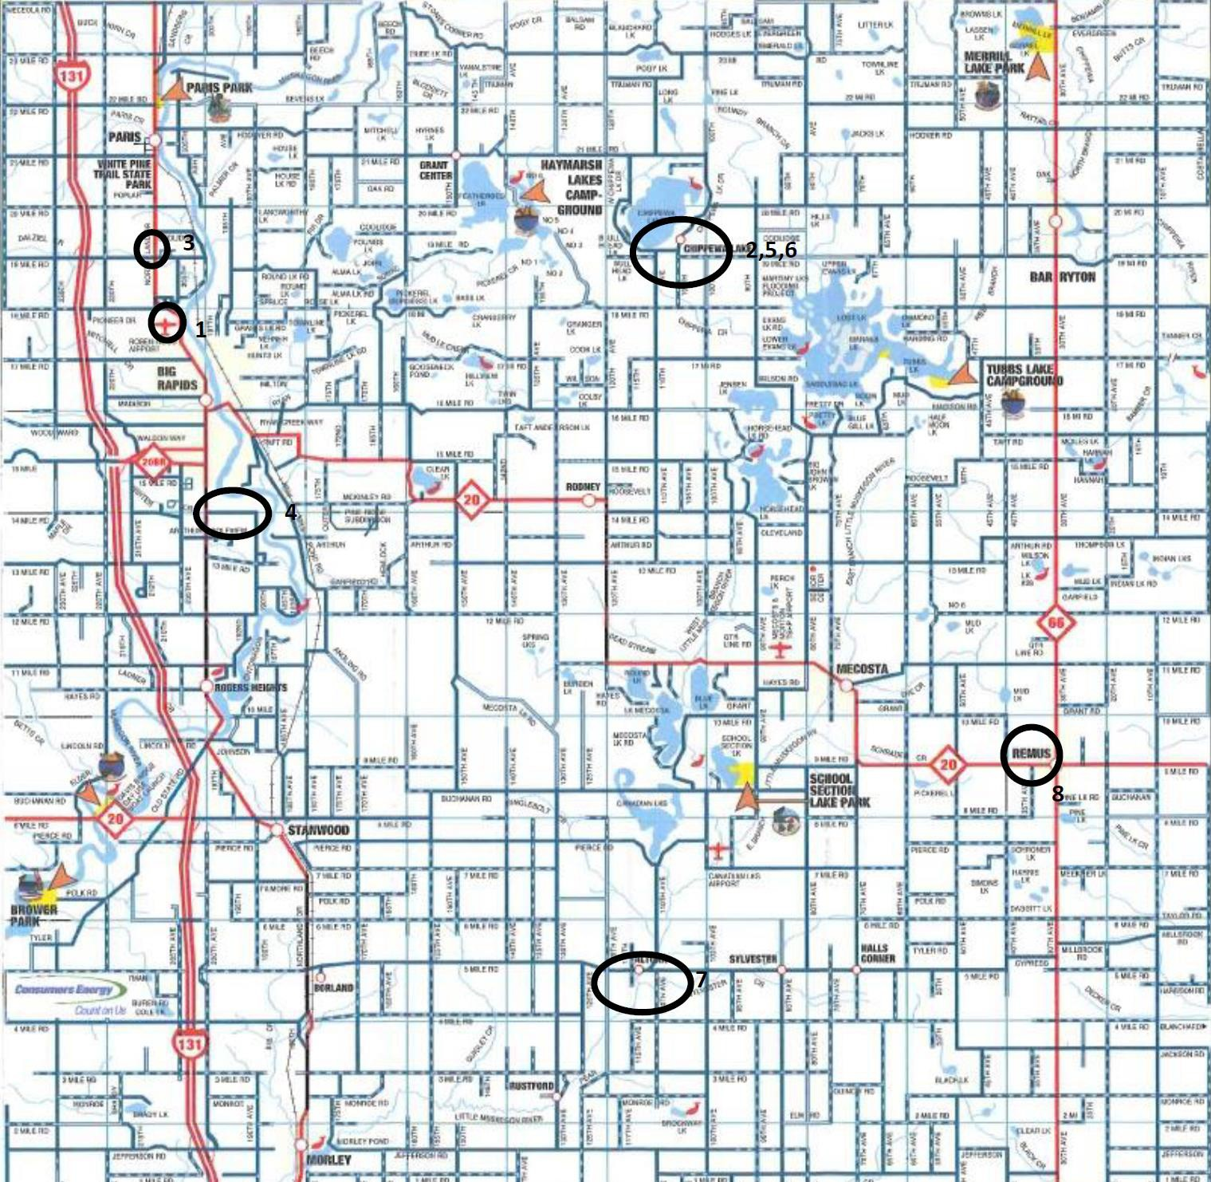

Township Recreational Facilities Inventory

Facility Name | Description | Owner
Charlie Brown Park | Playgrounds, athletic field, and court games | Green Township
Community  Building | Picnicking, playground, restroom, shelters, athletic field, court  games, and trails | Chippewa  Township
Green Township Town Hall Park | Picnicking, playgrounds, court games, trails, and historical site | Green Township
Highbanks Park | Picnicking, playgrounds, swimming, fishing, restroom, shelters, athletic field, water sports, and trails | Big Rapids Township
Millet Park | Picnicking, shelters, and court games | Chippewa Township
Mitchell’s Landing | Swimming beach and canoe/kayak landing | Chippewa Township
Altona Community Park | Pavilion, picnicking, restrooms, canoe/kayak launch on river | Hinton Township
Riverside Park | Canoe/kayak landing, picnicking, fishing, restroom, shelters, nature area, and court games | Hinton Township
Wheatland Township Park | Picnicking, playgrounds, restroom, pavilion, basketball court, and baseball fields | Wheatland Township
Morton Township Canoe  Launch | Canoe/kayak landing and picnicking | Morton Township

Additional Mecosta County Villages Recreational Facilities Inventories Map
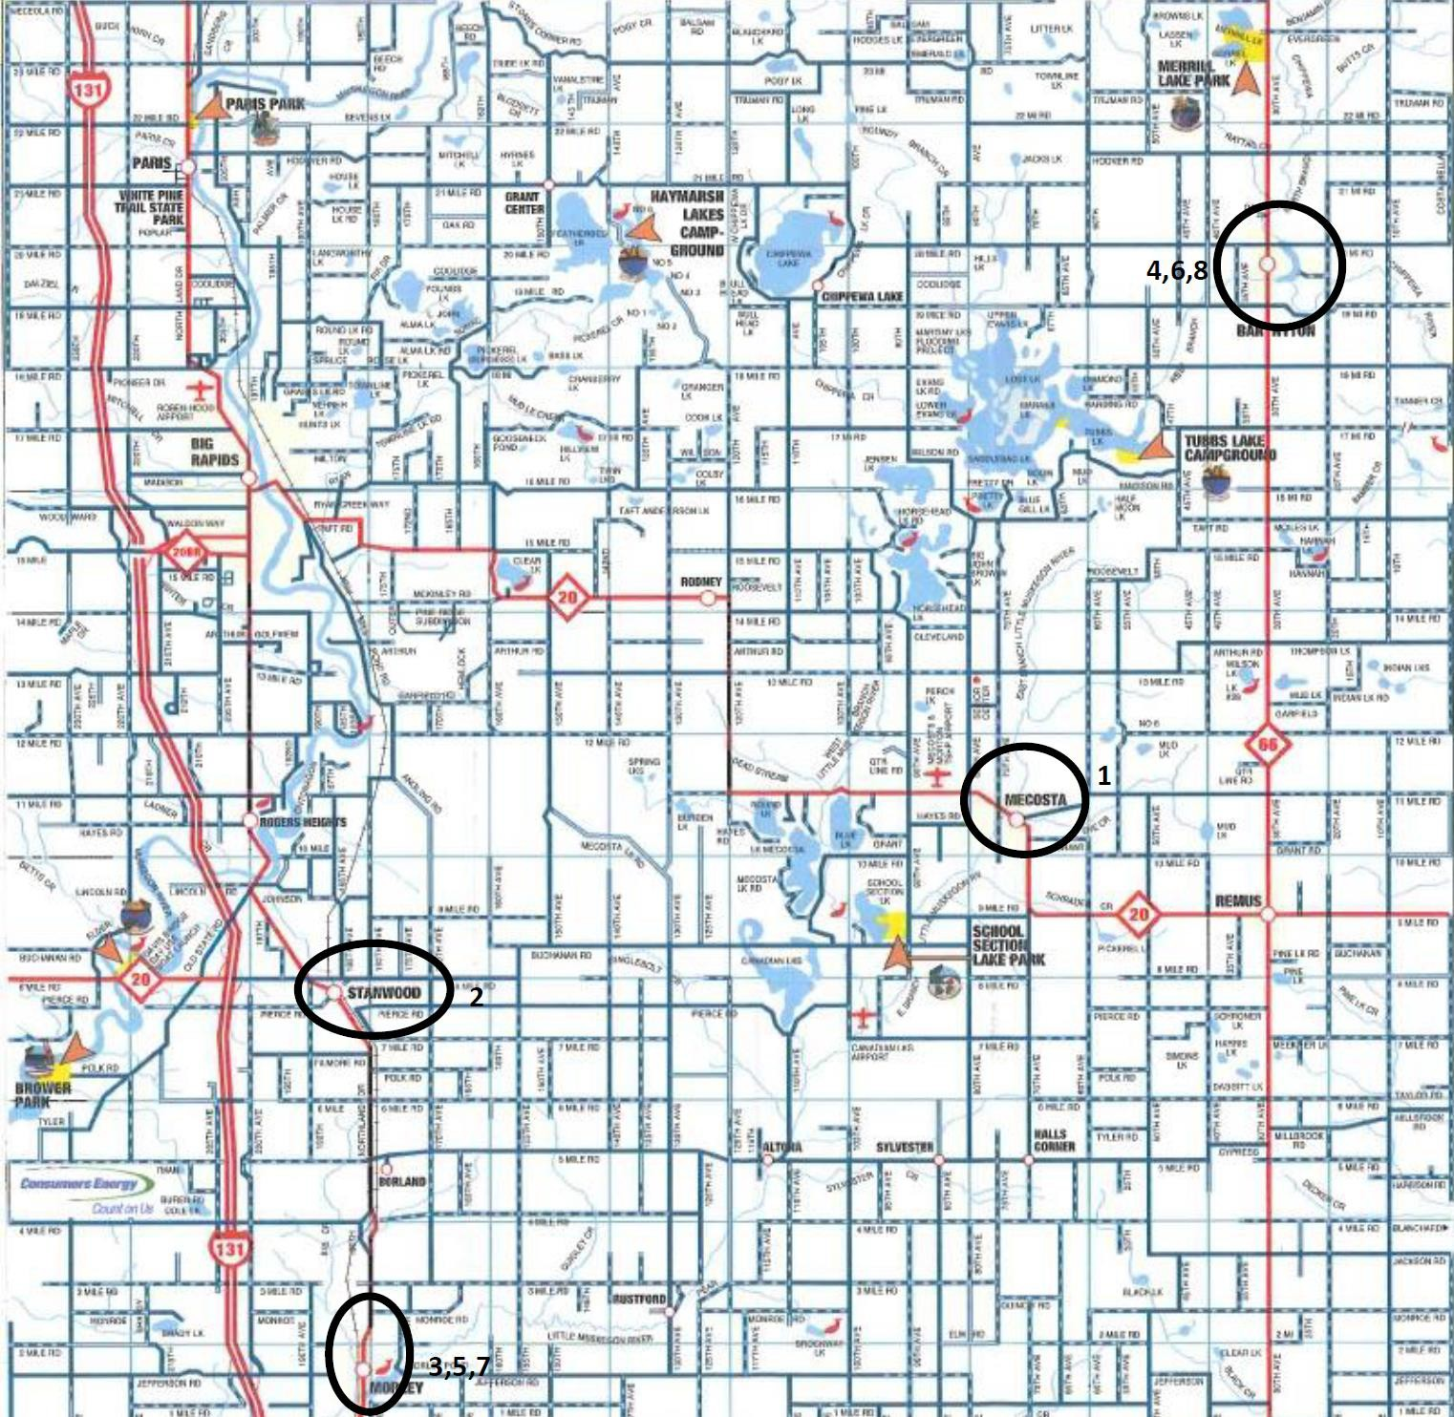

Additional Mecosta County Villages Recreational Facilities Inventories

Facility Name | Description | Owner
Bromley Park | Picnicking, playgrounds, fishing, restroom, shelters, and programming | Village of Mecosta
Buffalo Park | Picnicking, playground, restroom, shelters, and athletic field | Village of  Stanwood
Clyde Clark Park | Picnicking, fishing, restroom, and boat launch | Village of Morley
L. Latimer Park | Picnicking, playgrounds, swimming, fishing, restroom, shelters, boat launch, nature area, and water sports | Village of Morley
Louise Kinney Park | Picnicking, playgrounds, restroom, shelters, and court games | Village of Morley

Area Schools Recreational Inventories Map
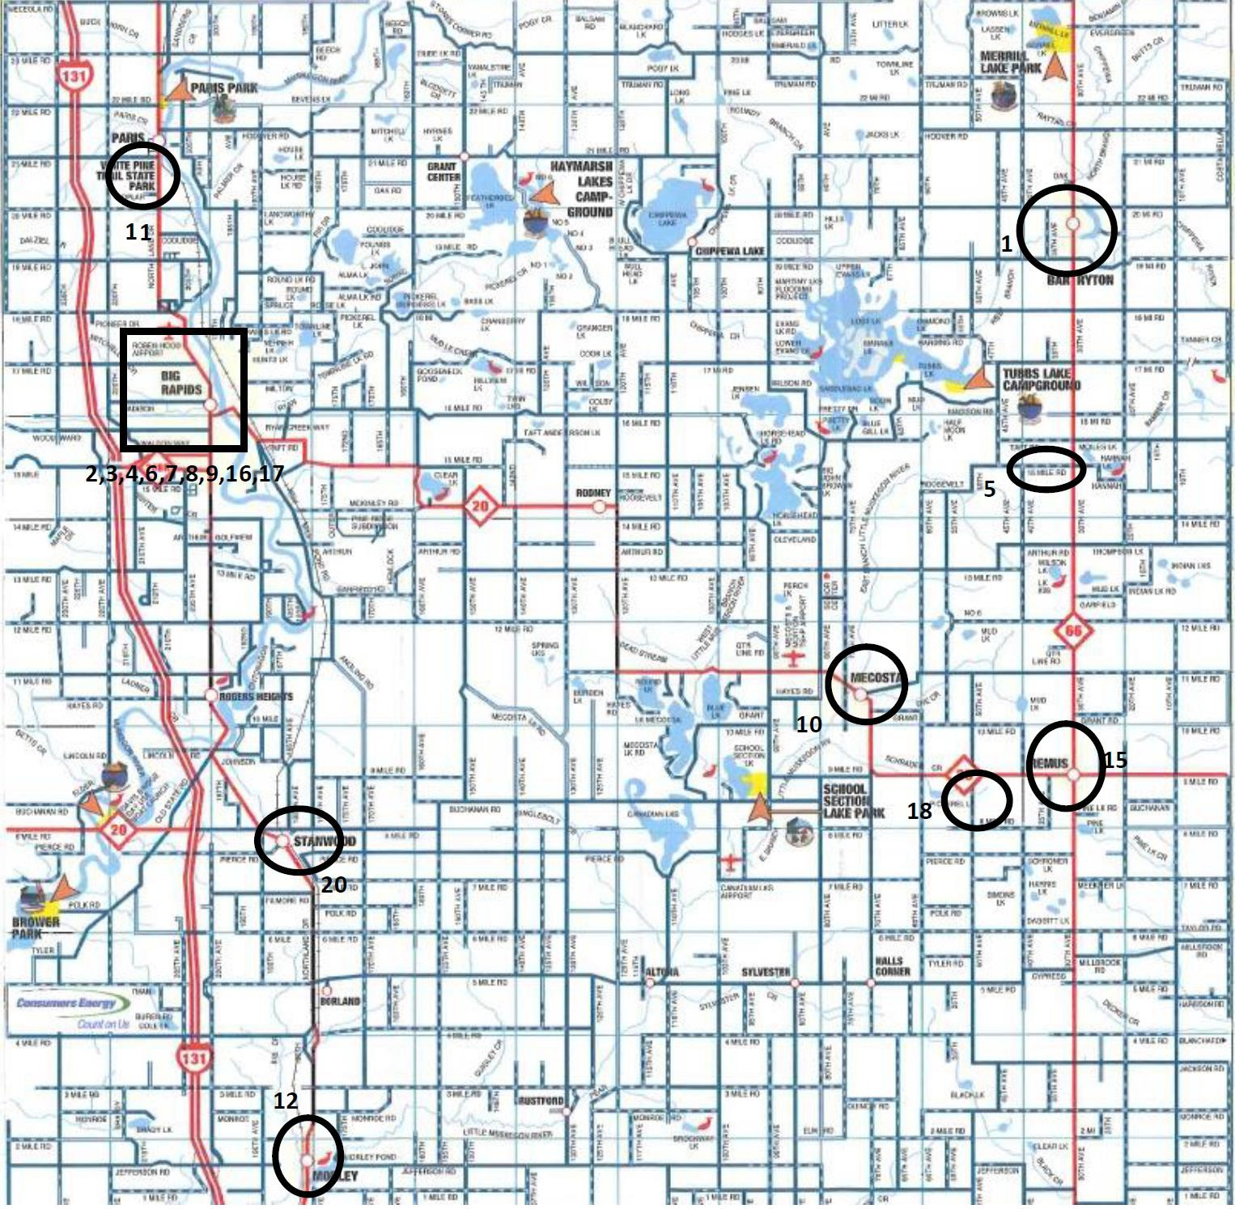

Area Schools Recreational Inventories

Facility Name | Description | Owner
Chippewa Hills  High School & Intermediate | Picnicking, playgrounds, restroom, shower, concessions, athletic field, court games, programming, and indoor sports/gym | Chippewa  Hills School District
Mecosta Elementary | Picnicking, playgrounds, athletic field, court games, and indoor sports/gym | Chippewa Hills School  District
Mecosta Osceola Intermediate School District | Picnicking, playgrounds, athletic field, programming, and indoor sports/gym | Mecosta and Osceola Counties
Morley Elementary | Picnicking, playgrounds, athletic field, court games, and indoor sports/gym | Morley  Stanwood Schools
Morley Stanwood High  School | Picnicking, playgrounds, restroom, shower, athletic field, court games, winter sports, programming, and indoor sports/gym | Morley Stanwood  Schools
Morley Stanwood  Middle School | Gym, football, softball, baseball, practice fields, indoor track, weight room, and multi-purpose courts, gym | Morley Stanwood  Schools
Remus Elementary | Picnicking, playgrounds, athletic field, court games, and indoor sports/gym | Chippewa  Hills School District
Riverview Elementary | Picnicking, playgrounds, athletic fields, court games, programming, and indoor sports | Big Rapids Schools
Stanwood Elementary | Picnicking, playgrounds, athletic field, court games, programming, and indoor sports/gym | Morley Stanwood Schools

City of Big Rapids Schools Recreational Facilities Inventories Map
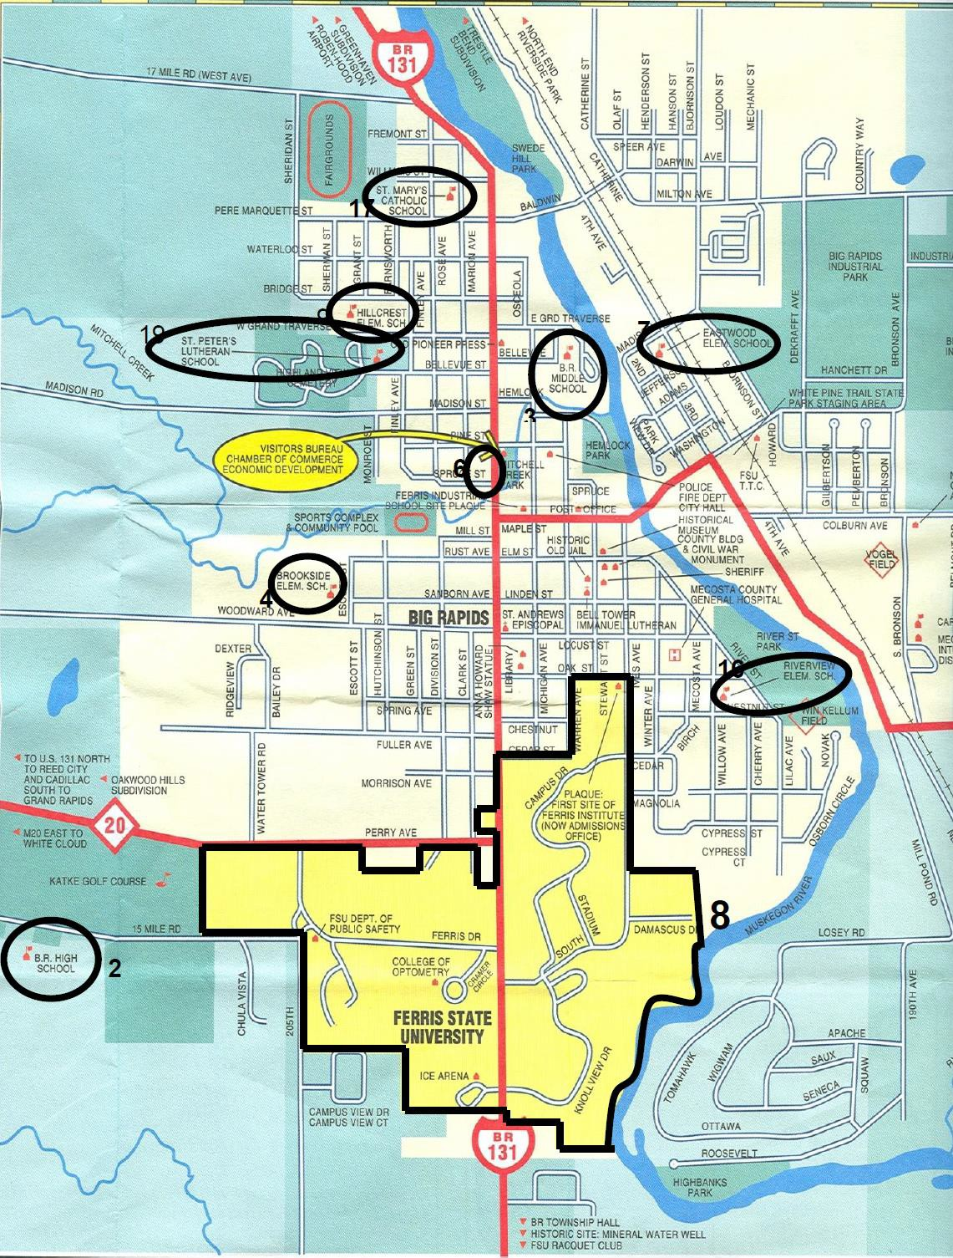

City of Big Rapids Schools Recreational Facilities Inventories

Facility Name | Description | Owner
Big Rapids High School | Gym, two football practice fields, two baseball diamonds, two soccer fields, seven tennis courts, track & football complex,  cross country trails, restroom, shower, athletic field, court games, winter sports, and indoor sports | Big Rapids Public Schools
Big Rapids Middle School | Gym soccer field, athletic field, court games, programming, and indoor sports | Big Rapids Public Schools
Brookside Elementary | Gym, baseball/softball field, playground, picnicking, athletic field, court games, programming, and indoor sports | Big Rapids Public Schools
Crossroads Charter  Academy | Two gymnasiums, soccer/football field, outdoor track & playground, playgrounds, athletic field, winter sports, trails, and  indoor sports | Crossroads Charter  Academy
Eastwood Elementary | Gym, baseball/softball field, playground, picnicking, athletic field, court games, programming, and indoor sports | Big Rapids Public Schools
Ferris State University – various facilities | Racquet & fitness center, indoor & outdoor tennis courts, two ice rinks, pool, climbing wall, indoor track, multi-purpose courts, weight room, multi-purpose fields, basketball courts,  football field, 18-hole golf course, indoor & outdoor track, | Ferris State University

State of Michigan Recreational Facilities Inventory Map
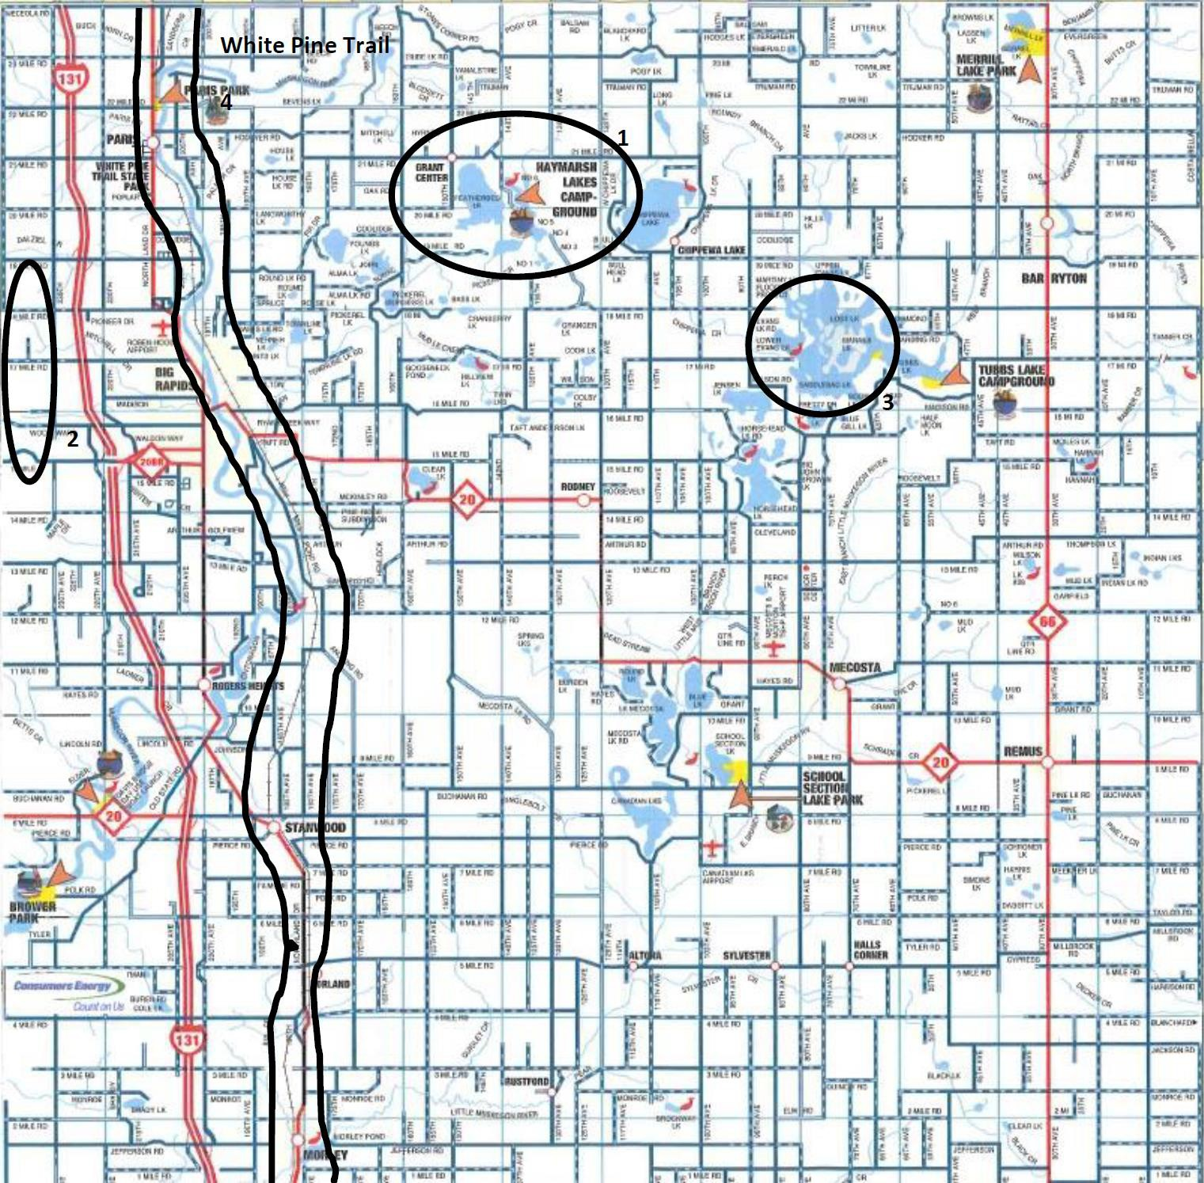

State of Michigan Recreational Facilities Inventory

Facility Name | Description | Owner
Haymarsh State Game Area | Camping, picnicking, hunting, fishing, restroom, nature area, and winter sports | State of Michigan Operated by Mecosta  County Park Commission
Manistee National Forest | Camping, hunting, fishing, nature area, winter sports, and water sports | State of Michigan
Tubbs Lake State Forest Campground | Camping, picnicking, swimming, hunting, fishing, restroom, boat launch, nature area, and water sports | State of Michigan Operated by Mecosta County Park  Commission
White Pine State Trail Park | Biking and hiking on linear trail | State of Michigan

Private Recreational Facilities Inventory Map
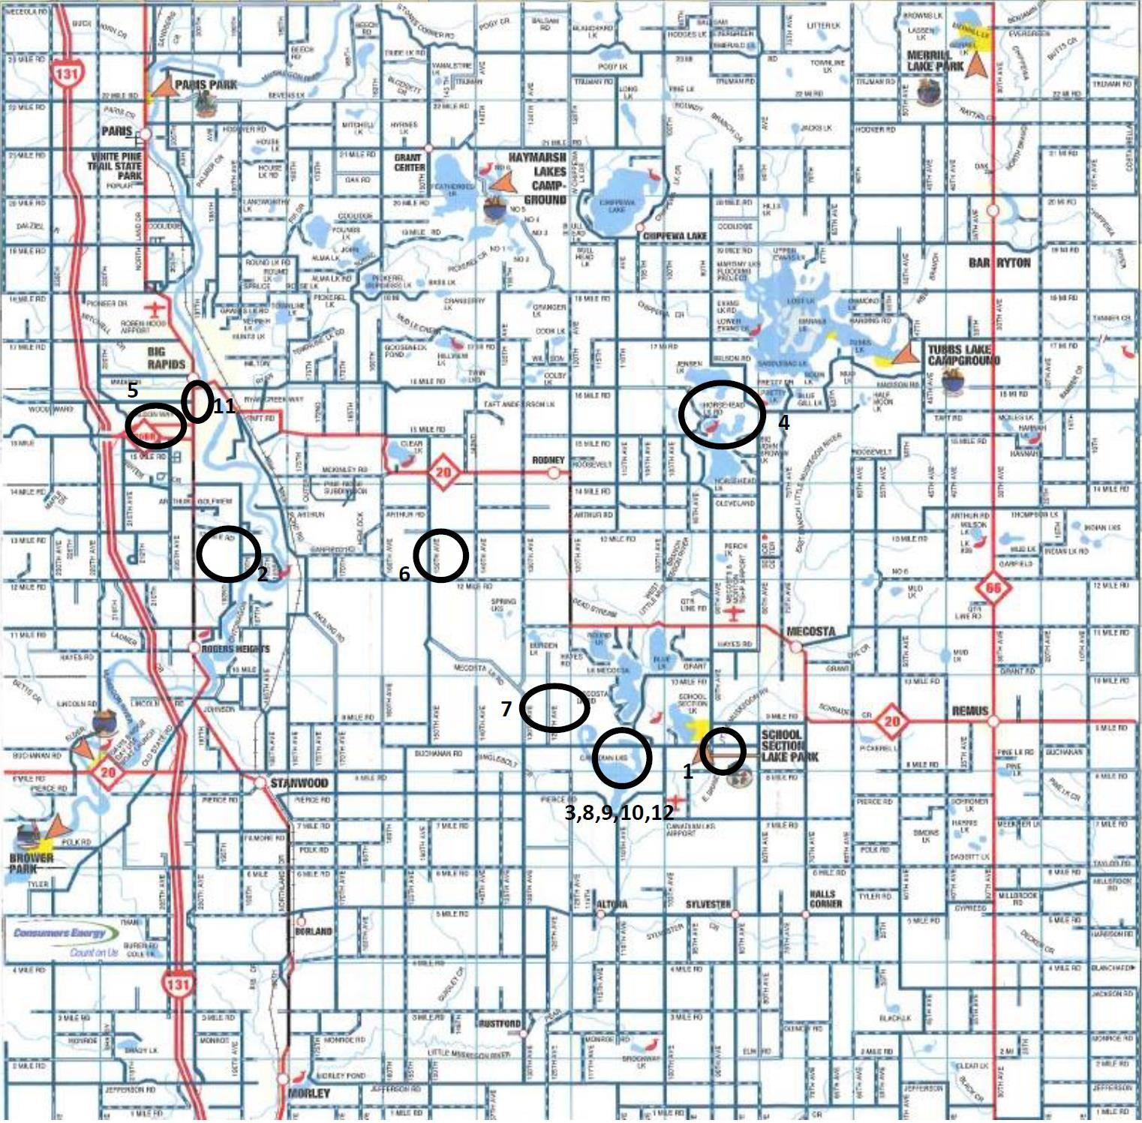

Private Recreational Facilities Inventory

Facility Name | Description | Owner
Adventure Island | Restroom, concessions, and golf course | Private
Falcon Head | Restroom concession, and golf course | Private
Highlands | Restroom, concessions, and golf course | Private
Horsehead Lake | Camping, picnicking, playgrounds, swimming, hunting, fishing,  restroom, shower, shelters, boat launch, athletic field, court games, water sports, and trails | Private
Katke Golf Course | Restroom, concessions, and golf course | Private –  Ferris State University
Meceola Country Club | Restroom, concessions, and golf course | Private
Outback Guest  Ranch Lodge & Equestrian | Camping, picnicking, playground, restroom, shower, shelters, concessions, nature area, court games, programming, and trails | Private
Pines Golf Course | Restroom, concessions, and golf course | Private
Royal Golf Course | Restroom, concessions, and golf course | Private
St. Ives & Tullymore Golf Clubs | Restroom, concessions, restaurants, and golf courses | Private
The Gate Family  Recreation Center | Restroom, concessions, and golf course | Private
Clear Lake Golf Course | Restroom, concessions, and golf course | Private
Barryton  Conservation Club | Trap skeet range, firing range, indoor & outdoor archery ranges, and concealed carry courses (CPL) | Private

Private Campground Facilities Inventory Map
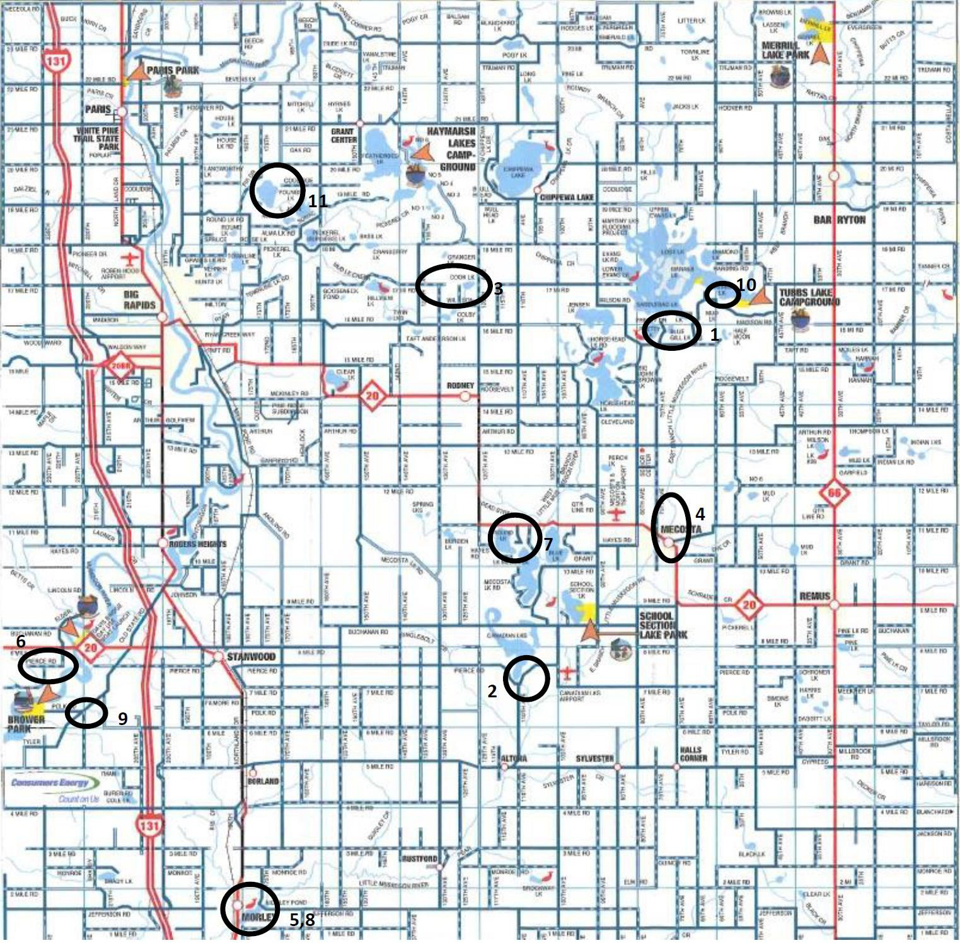

Private Campground Facilities Inventory

Facility Name | Description | Owner
Bluegill Lake Campground | Camping, picnicking playgrounds, swimming, hunting, fishing,  restroom, shower, shelters, concessions, boat launch, nature center, and water sports | Private Campground
Canadian Lakes Campground | Camping, picnicking, playgrounds, swimming, fishing, restroom, shower, shelters, concessions, boat launch, nature area, athletic field, court games, winter sports, water sports,  programming, trails, golf course, and indoor sports | Private Campground
Cran-Hill Ranch | Camping, picnicking, playgrounds, swimming, hunting, fishing, restroom, shower, shelters, concessions, boat launch, nature area, athletic field, court games, winter sports, water sports,  programming, trails, indoor sports, and group camps | Private Campground
Holiday  Terrance Campground | Camping, picnicking, playgrounds, swimming, fishing,  restroom, shower, concessions, boat launch, nature area, court games, and water sports | Private Campground
Mecosta Pines Campground | Camping, picnicking, playgrounds, swimming, fishing, restroom, shower, nature area, water sports, programming, and  indoor sports | Private Campground
River Ridge Resort | Camping, picnicking, swimming, fishing, restroom, shower, shelters, concessions, boat launch, nature area, court games, water sports, trails, and group camps | Private Campground
Round Lake Resort | Camping, picnicking, playgrounds, swimming, fishing restroom, shower, and nature area | Private Campground
Sarn’s Resort | Camping, picnicking, playgrounds, swimming, hunting, fishing restroom, shower, and shelters | Private Campground
Martiny Lakes Hide-Away | Camping, restroom, cottages, fishing, boating, and shower | Private Campground
Tubbs Resort | Camping, picnicking, swimming, fishing, restroom, shower,  concessions, boat launch, court games, winter sports, water sports, and trails | Private Campground
Youngs Lake Campground | Camping, picnicking, swimming, hunting, fishing, restroom, shower, boat launch, court games, and water sports | Private Campground

Action Plans

Analysis of Needs, Goals & Actions

Fork Township and the Village of Barryton are blessed with many outdoor recreational activities. In addition to their local recreation facilities, there are many county, state, and other local municipal and federal facilities. The village and township have mini-parks, neighborhood parks, school playgrounds, and the community parks. Fork Township owns approximately 111 acres of undeveloped land that is proposed to be developed as a large township regional park that could include cross country skiing, all terrain bike trails, hiking, and camping. As outlined in the “Inventory” section of the plan, there are numerous county, state, and private facilities nearby. These include many activities at Ferris State University and the state White Pine Hiking and Biking Trail that traverses the west side of the county north to south. There is also an equestrian trail area run by the U.S. Forest Service just west of Big Rapids in Newaygo County. Horse riding groups and clubs also use the Mecosta County Fairgrounds for riding events.

In terms of specific sports, Barryton and Fork Township also lack few facilities. Many sports activities are offered by the schools. The elementary school in Barryton has a gymnasium where basketball and other sports are offered. Ferris State University provides numerous facilities including an ice hockey rink, volleyball courts, running tracks, and a golf course. The Fork Township Community Center has baseball and softball fields. The school has soccer fields and basketball hoops as well as playground equipment. The Barryton Conservation Club has archery ranges and gun ranges with skeet and trap. There are swimming pools in Big Rapids and ample lakes and rivers for swimming, boating, and fishing. The School Section Lake Veterans Park beach is where many county residents learned to swim. And there are numerous private golf courses nearby in the county and regionally.

The primary goal of the Village of Barryton and Fork Township is to provide quality recreation opportunities for all our citizens and visitors to the community. In order to accomplish this, the joint recreation plan includes actions to improve the existing facilities and to add ones that compliment those that already exist. Needs by different groups are addressed – more basketball courts, pickleball courts, expanded walking and hiking trails, and soccer fields. Additional paved parking and pathways as well as restrooms are proposed to improve accessibility. Trails that connect the village and township with state trails, the school, and other parks will expand the reach of local facilities. The proposed development of the township M-66 property, including cross country skiing, hiking and biking activities, and rustic camping, could add a whole new gamut of recreation activities for the township and village residents and visitors to the area.

The Proposed Recreation Projects Schedule that follows outlines these projects over the five years of this plan and beyond.

Village of Barryton and Fork Township Future Proposed Recreational Projects

Village of Barryton

Year One

Central Park:
- Add basketball court on Museum slab - $7,000
- Install park entry signs - $7,500

East River Park:
- Construct concrete boat launch and fishing pier along with pond access with parking -
$70,000
- Construct restroom - $75,000 Year Two
Central Park:
- Two shuffle board courts - $40,000
- Develop Soccer field with goals nets - $25,000
- Construct a Bandstand - $25,000
- Set up an ice rink at farmers Market - $15,000 Year Three
Central Park:
- Build an additional Tennis Court
- Add Two to four pickleball courts
- Pave a path to complete loop around park +/- ½ mile and link to picnic pavilions and parking at the Barryton Museum (possible bollard lighting) - $130,000
- Install a tennis practice board - $35,000 Year Four
Central Park:
- Construct a splash park for kids - $100,000
- A playscape at gazebo area -$60,000

East River Park:
- Dredge area and build sand beach for swimming and other water activities - $25,000

Riverside Park:
- Construct pathway along frontage (asphalt, wood chips, gravel) - $10,000

Year Five

Central Park:
  - Construct a full-sized basketball court with two backboards on sides $30,000

Riverside Park:
  - Dredge - $25,000 to $50,000

Fork Township

Community Center
- 2023 Replace basketball backboards - $3,000
- 2023 Renovation of Community Center (to include: conversion of fluorescent light fixtures
to LED; installation of new exterior doors and windows; interior and exterior paint) - $100,000
- 2023 Construct 480 square foot pavilion near playscape in recreational park - $20,000
- 2023 Resurface parking lot - $10,000
- 2024 Rehabilitate restrooms in recreational park - $50,000
- 2024 Install roadside electronic marquee - $7,000
- 2025 Landscape Community Center and recreational park area - $50,000
- 2025 Renovate restrooms in Community Center - $30,000
- 2026 Create a dog park - $45,000
- 2026 Make improvements to truck/tractor pull area - $25,000
- 2027 Upgrade lighting in recreational park area - $20,000
- 2027 Plant a Veteran’s memorial garden - $30,000

Appendix

Potential Sources of funding
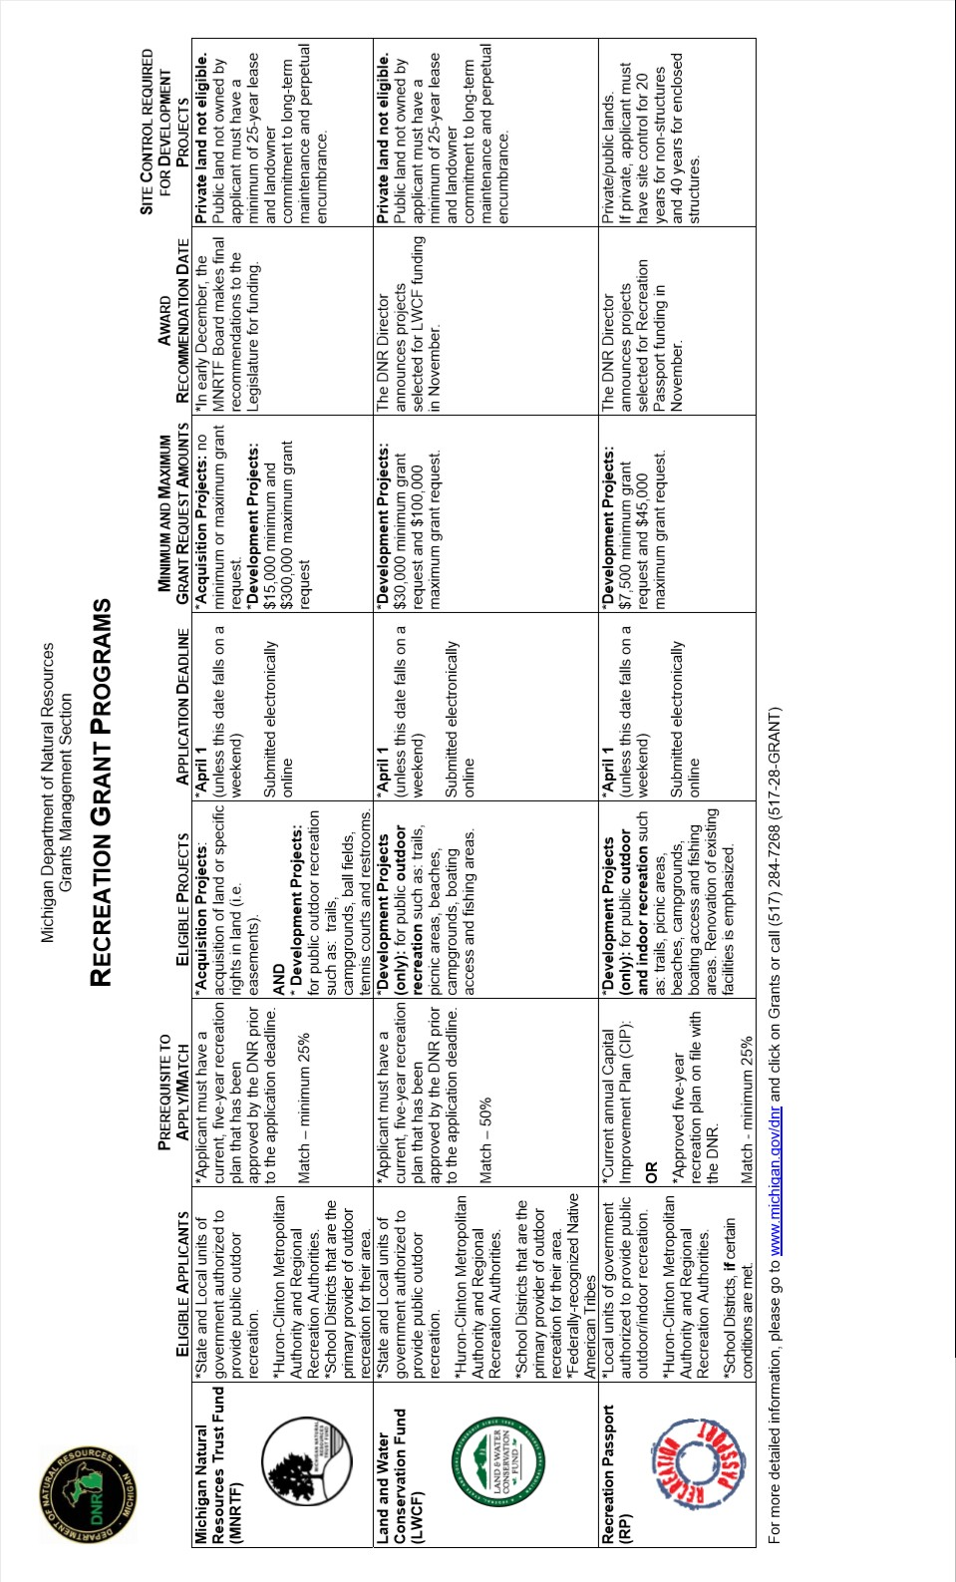

A Recommended Classification System for Local and Regional Recreation Open Space

This classification system is intended to serve as a guide to planning—not as an absolute blueprint. Sometimes more than on component may occur within the same site (but not on the same parcel of land), particularly with respect to special uses within a regional park. Planners of park and recreation systems should be careful to provide adequate land for each functional component when this occurs.

The National Recreation and Park Association suggests that a park system, at a minimum, be composed of a “core” system of parklands, with a total of 6.25 to 10.5 acres of developed open space per 1,000 population. The size and amount of “adjunct” parklands will vary from community to community, but must be taken into account when considering a total, well- rounded system of parks and recreation areas.

COMPONENT | USE | SERVICE  AREA | DESIRABLE  SIZE | ACRES/1,000  POPULATION | DESIRABLE SITE CHARACTERISTICS
A. LOCAL/CLOSE –TO-HOME SPACE:
Mini-Park | Specialized facilities that serve a concentrated or limited population or specific group such as tots  or senior citizens. | Less than ¼ mile radius. | 1 acre or less | 0.25 to 0.5 A | Within neighborhoods and in close proximity to apartment complexes, townhouse development  or housing for the elderly.
Neighborhood | Area for intense | ¼- to ½-mile | 15+ acres | 1.0 to 2.0 A | Suited for intense
Park/ | recreational activities, such | radius to serve a |  |  | development. Easily
Playground | as a field games, court  games, crafts, playground | population up to  5,000 (a |  |  | accessible to neighborhood  population, geographically
 | apparatus area, skating, | neighborhood). |  |  | centered with safe walking
 | picnicking, wading pools, |  |  |  | and bike access. May be
 | etc. |  |  |  | developed as a school park
 |  |  |  |  | facility.
Community | Area of diverse | Several | 25+ acres | 5.0 to 8.0 A | May include natural
Park | environmental quality.  May include areas suited | neighborhoods.  1 to 2 mile |  |  | features, such as water  bodies, and areas suited for
 | for intense recreational | radius. |  |  | intense development.
 | facilities, such as athletic |  |  |  | Easily accessible to
 | complexes, or large |  |  |  | neighborhood served.
 | swimming pools, May be
 | an area of natural quality
 | for outdoor recreation,
 | such as walking, viewing,
 | sitting, or picnicking. May
 | be any combination of the
 | above, depending upon
 | site suitability and
 | community need.
TOTAL CLOSE-TO-HOME SPACE = 6.25-10.5 A/1,000

COMPONENT | USE | SERVICE  AREA | DESIRABLE  SIZE | ACRES/1,000  POPULATION | DESIRABLE SITE CHARACTERISTICS
B. REGIONAL SPACE:
Regional/ | Areas of natural or | Several | 200+ acres | 5.0 to 10.0 A | Contiguous to or
Metropolitan | ornamental quality for | communities. 1 |  |  | encompassing natural
Park | outdoor recreation, such as  picnicking, boating, fishing, | hour driving  time. |  |  | resources.
 | swimming, camping, and
 | trail uses; may include play
 | areas.
Regional Park | Area of natural quality for | Several | 1,000+ acres; | Variable | Diverse or unique natural
Reserve | nature-oriented outdoor  recreation, such as viewing | Communities.  1 hour driving | sufficient area  to encompass |  | resources, such as lakes,  streams, marshes, flora,
 | and studying nature, | time. | the resource |  | fauna, or topography.
 | wildlife habitat, |  | to be
 | conservation, swimming, |  | preserved and
 | picnicking, hiking, fishing, |  | managed.
 | boating, camping, and trail
 | uses. May include active
 | play areas. Generally, 80%
 | of the land is reserved for
 | conservation and natural
 | resource management,
 | with less than 20% used for
 | recreation development.
TOTAL REGIONAL SPACE = 15-20 A/1,000
C. SPACE THAT MAY BE LOCAL OR REGIONAL AND IS UNIQUE TO EACH COMMUNITY:
Linear Park | Area developed for one or | No applicable | Sufficient | Variable | Built or natural corridors,
 | more varying modes of | standard. | width to |  | such as utility rights-of-
 | recreational travel, such as |  | protect the |  | way, bluff lines, vegetation
 | hiking, biking, |  | resource and |  | patterns, and roads, that
 | snowmobiling, horseback |  | provide |  | link other components of
 | riding, cross-country skiing, |  | maximum use. |  | the recreation system or
 | canoeing and pleasure |  |  |  | community facilities, such
 | driving. May include active |  |  |  | as school, libraries,
 | play areas. |  |  |  | commercial areas, and
 | (NOTE: any included for |  |  |  | other park areas.
 | any of above components
 | may occur in the “linear
 | park”).
Special Use | Areas for specialized or single purpose recreational activities, such as golf courses, nature centers, marinas, zoos, conservatories, arboreta, display gardens, arenas, outdoor theaters, gun ranges, or downhill ski areas, or areas that preserve, maintain, and interpret buildings, sites, and objects of archeological significance.  Also plazas or squares in or near commercial centers, | No applicable standard. | Variable depending on desired size. | Variable | Within communities.

COMPONENT | USE | SERVICE  AREA | DESIRABLE  SIZE | ACRES/1,000  POPULATION | DESIRABLE SITE CHARACTERISTICS
 | boulevards, or parkways.
Conservancy | Protection and | No applicable | Sufficient to | Variable | Variable, depending on the
 | management of the | standard. | protect the |  | resource being protected.
 | natural/cultural |  | resource.
 | environment with
 | recreation use as a
 | secondary objective.

Adapted From:

Suggested Facility Development Standards

Lancaster, R. A., Ed. Recreation, Park and Open Space Standards and Guidelines. Alexandria, VA: National Recreation and Park Association, 1983.
Mertes, J. D. and J. R. Hall. Park, Recreation, Open Space and Greenway Guidelines. Alexandria, VA: National Recreation and Park Association, 1995.
Activity/  Facility | Recommended Space  Requirements | Recommended Size and  Dimensions | Recommended Orientation | No. of Units Per  Population | Service Radius | Location Notes
Badminton | 1620 sq. ft. | Singles – 17’x44’ Doubles – 20’x44’ With 5’ unobstructed area on all sides | Long axis north- south. | 1 per 5,000 | ¼ - ½ mile | Usually in school, recreation center or church facility. Safe walking or bike  access.
Basketball  - Youth  - High School  - Collegiate | 2400-3036 sq.  ft.  5040-7280 sq.  ft.  5600-7980 sq.  ft. | 46’-50’x84’  50’x84’  50’x94’  with 5’ unobstructed  space on all sides. | Long axis north- south. | 1 per 5,000 | ¼ - ½ mile | Same as badminton. Outdoor courts in neighborhood and community parks, plus active recreation areas in other park settings.
Handball (3-4 wall) | 800 sq. ft. for 4-wall.  1000 sq. ft. for 3-wall | 20’x40’ – Minimum of 10’ to rear of 3-wall court. Minimum 20’ overhead clearance. | Long axis north- south. Front wall at north end. | 1 per  20,000 | 15-30  minutes travel time | 4-wall usually indoor as part of multi- purpose facility. 3- wall usually outdoor in park or school  setting.
Ice Hockey | 22,000 sq. ft. including support area. | Rink 85’x200’ (minimum 85’x185’. Additional 5,000 sq. ft. support area). | Long axis north- south if outdoor. | Indoor – 1 per 100,000.  Outdoor –  depends on climate. | ½ - 1 hour travel time | Climate important considerations affecting number of units. Best as part of multi-purpose facility.
Tennis | Minimum of 7,200 sq. ft.  single court. (2 acres for  complex.) | 36’x78’. 12’ clearance on both sides; 21’ clearance on both ends. | Long axis north- south. | 1 court per  2, 000 | ¼ - ½ mile | Best in batteries of 2-  4. Located in neighborhood/comm unity park or adjacent  to school site.
Volleyball | Minimum of 4, 000 sq. ft. | 30’x60’. Minimum 6’  clearance on all sides. | Long axis north- south. | 1 court per  5,000 | ¼ - ½ mile | Same as other court activities (e.g. badminton,  basketball, etc.)
Baseball  - Official  - Little League | 3.0-3.85 A  minimum  1.2 A minimum | - Baselines - 90’ Pitching distance - 60½’ Foul lines - min. 320’ Center field - 400’+  - Baseline – 60’ Pitching distance – 46’ Foul lines – 200’  Center field – 200’-250’ | Locate home plate so pitcher throwing across sun and batter not facing it.  Line from home plate through pitcher’s mound run east- northeast. | 1 per 5, 000 | ¼ - ½ mile | Part of neighborhood complex. Lighted fields part of community complex.
Field Hockey | Minimum 1.5 A | 180’x300’ with a | Fall season-long | 1 per | 15-30 | Usually part of

Activity/  Facility | Recommended Space  Requirements | Recommended Size and  Dimensions | Recommended Orientation | No. of Units Per  Population | Service Radius | Location Notes
 |  | minimum of 10’  clearance on all sides. | axis northwest to southeast. For longer periods, north to south. | 20,000 | minutes travel time | baseball, football, or soccer complex in community park or adjacent to high  school.
Football | Minimum 1.5 A | 160’x360’ with a  minimum of 6’ clearance  on all sides. | Same as field hockey. | 1 per  20,000 | 15-30  minutes travel time | Same as field hockey
Soccer | 1.7 to 2.1 A | 195’ to 225’x330’ to 360’  with a 10’ minimum  clearance on all sides. | Same a field hockey. | 1 per  10,000 | 1-2 miles | Number of units depends on popularity. Youth soccer on smaller fields adjacent to schools or  neighborhood parks.
Golf-Driving Range | 13.5 A for  minimum of 25 tees | 900’x690’ wide. Add 12’ width for each additional tee. | Long axis southwest/north  -east with golfer driving toward  northeast. | 1 per  50,000 | 30 minutes travel time | Part of golf course complex as a separate unit. May be privately operated.
¼-Mile Running Track | 4.3 A | Overall width – 276’  Length – 600.02’  Track width for 8 to 4  lanes is 32’. | Long axis in sector from north to south to northwest/ southeast with finish line at  northerly end. | 1 per  20,000 | 15-30  minutes travel time | Usually part of high school or in community park complex in combination with football, soccer, etc.
Softball | 1.5 to 2.0 A | Baselines – 60’  Pitching distance –46’ min., 40’ – women Fast pitch field radius from plate – 225’  Slow pitch – 275’  (men), 250’ (women) | Same as baseball. | 1 per  50,000 (if  also used for youth baseball) | ¼ - ½ mile | Slight difference in dimensions for 16” slow pitch. May be used for youth baseball.
Multiple Recreation Court (basketball, volleyball,  tennis) | 9,840 sq. ft. | 120’x80’ | Long axis of courts with primary use is north-south. | 1 per  10,000 | 1-2 miles
Trails | N/A | Well defined head,  maximum 10’ width, maximum average grade 5% not to exceed 15%. Capacity rural trails - 40 hikers/day/mile. Urban  trails – 90 hikers/day/mile. | N/A | 1 system per region | N/A
Archery Range | Minimum 0.65 A | 300’ length x minimum 10’ wide between targets. Roped clear space on sides of range minimum of 30’ clear space behind targets,  minimum of 90’x45’ with | Archer facing north + or – 45 degrees. | 1 per  50,000 | 30 minutes travel time | Part of a regional/metro park complex.

Activity/  Facility | Recommended Space  Requirements | Recommended Size and  Dimensions | Recommended Orientation | No. of Units Per  Population | Service Radius | Location Notes
 |  | bunker.
Combination Skeet and Trap Field  (8 station) | Minimum 30 A | All walks and structures occur within an area approximately 130’ wide by 115’ deep. Minimum cleared area is contained within two superimposed segments with 100-yard radii (4 acres). Shot-fall danger zone is contained within two superimposed segments with 300-yard  radii (36 acres). | Centerline of length runs northeast/south- west with shooter racing northeast. | 1 per  50,000 | 30 minutes travel time | Part of regional/metro park complex.
Golf  - Par 3 (18-  hole)  - 9-hole standard  - 18-hole standard | - 50-60 A  - Minimum 50 A  - Minimum 110 A | - Average length-vary 600-2700 yards  - Average length-2250 yards  - Average length-6500 yards | Majority of holes on north-south axis. | - 1/25,000  - 1/50,000 | ½ to 1 hour travel time | 9-hole course can accommodate 350 people/day. 18-hole course can accommodate 500- 550 people a day.  Course may be located in community or district park, but should not be over 20 miles from population  center.
Swimming Pools | Varies on size of pool and amenities.  Usually ½ to 2 A site. | Teaching – minimum of  25 yards x 45’ even  depth of 3 to 4 feet. Competitive – minimum of 25m x 16m.  Minimum of 27 square feet of water surface per swimmer. Ratios of 2:1, deck vs. water. | None-although care must be taken in siting of lifeguard stations in relation to afternoon sun. | 1 per  20,000  (Pools should accommoda te 3 to 5% of total population at a time.) | 15 to 30 minutes travel time | Pools for general community use should be planned for teaching, competitive, and recreational purposes with enough depth (3.4m) to accommodate 1m and 3m diving boards.  Located in community  park or school site.
Beach Areas | N/A | Beach area should have 50 sq. ft. of land and 50 sq. ft. of water per user. Turnover rate is 3.  There should be a 3-4 A supporting land per A of  beach. | N/A | N/A | N/A | Should have sand bottom with slope a maximum of 5% (flat preferable). Boating areas completely segregated from  swimming areas.

Grant History

